**Lab10 – Capturing existing VM & build new VM with customized Image using Managed Disks**

### Managed disks

Managed Disks handles the storage account creation/management in the background for you, and ensures that you do not have to worry about the scalability limits of the storage account. You simply specify the disk size and the performance tier (Standard/Premium), and Azure creates and manages the disk for you. As you add disks or scale the VM up and down, you don't have to worry about the storage being used.

You can also manage your custom images in one storage account per Azure region, and use them to create hundreds of VMs in the same subscription. For more information about Managed Disks, see the [Managed Disks Overview](https://docs.microsoft.com/en-us/azure/virtual-machines/windows/managed-disks-overview).

We recommend that you use Azure Managed Disks for new VMs, and that you convert your previous unmanaged disks to managed disks, to take advantage of the many features available in Managed Disks.

**Images**

Managed Disks also support creating a managed custom image. You can create an image from your custom VHD in a storage account or directly from a generalized (sys-prepped) VM. This process captures in a single image all managed disks associated with a VM, including both the OS and data disks. This managed custom image enables creating hundreds of VMs using your custom image without the need to copy or manage any storage accounts.

**Topology**

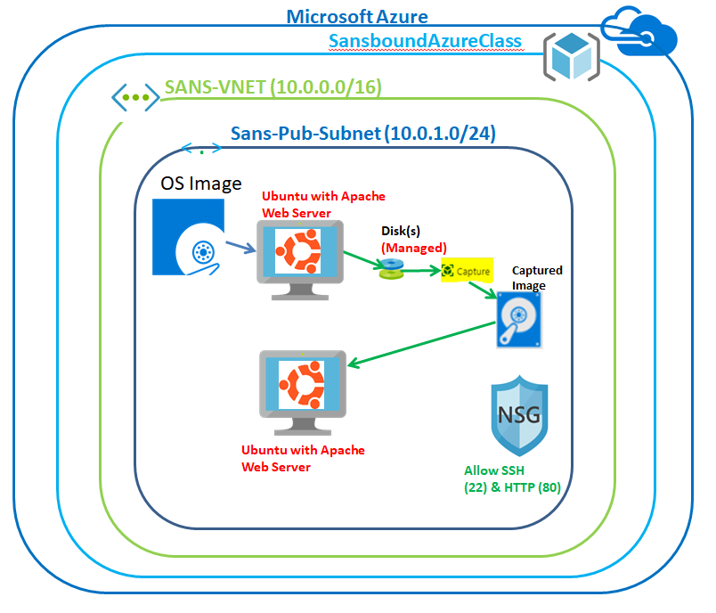

In Azure portal, click on **“Resource groups”** in left side panel.

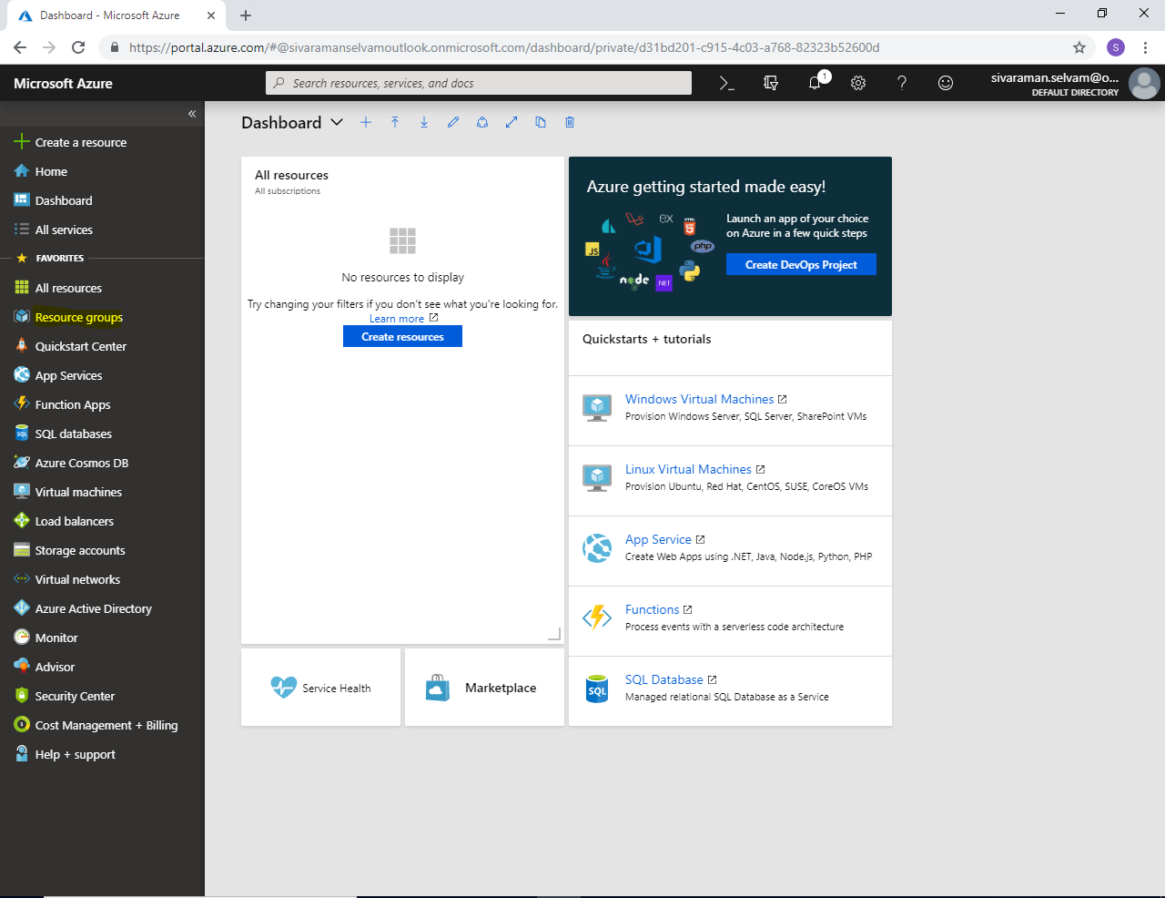

Click **“Add”**.

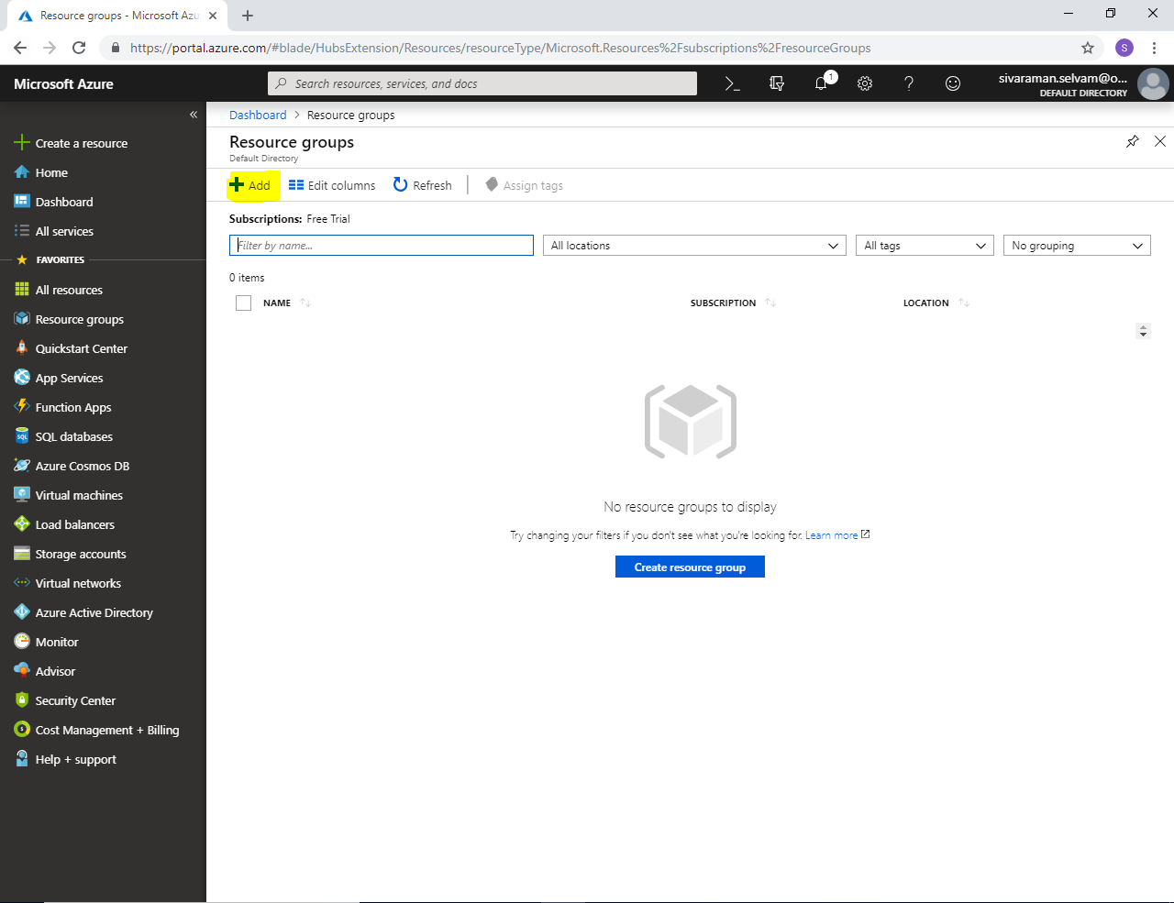

While creating **“Resource group”**.

Type **“Resource group name”** as **“SansboundAzureClass”**.

Select **“Subscription”** as **“Free Trial”**.

Select **“Resource group location”** as **“South India”**.

Then click **“Create”**.

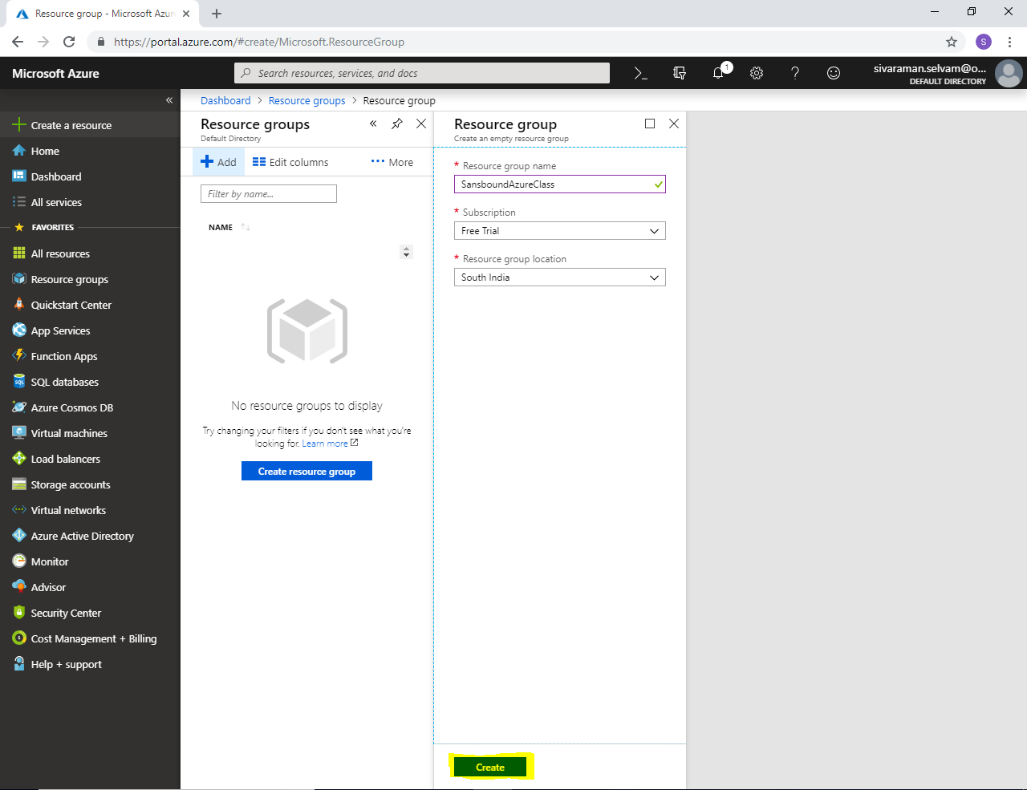

Click **“Virtual networks”** in left side panel.

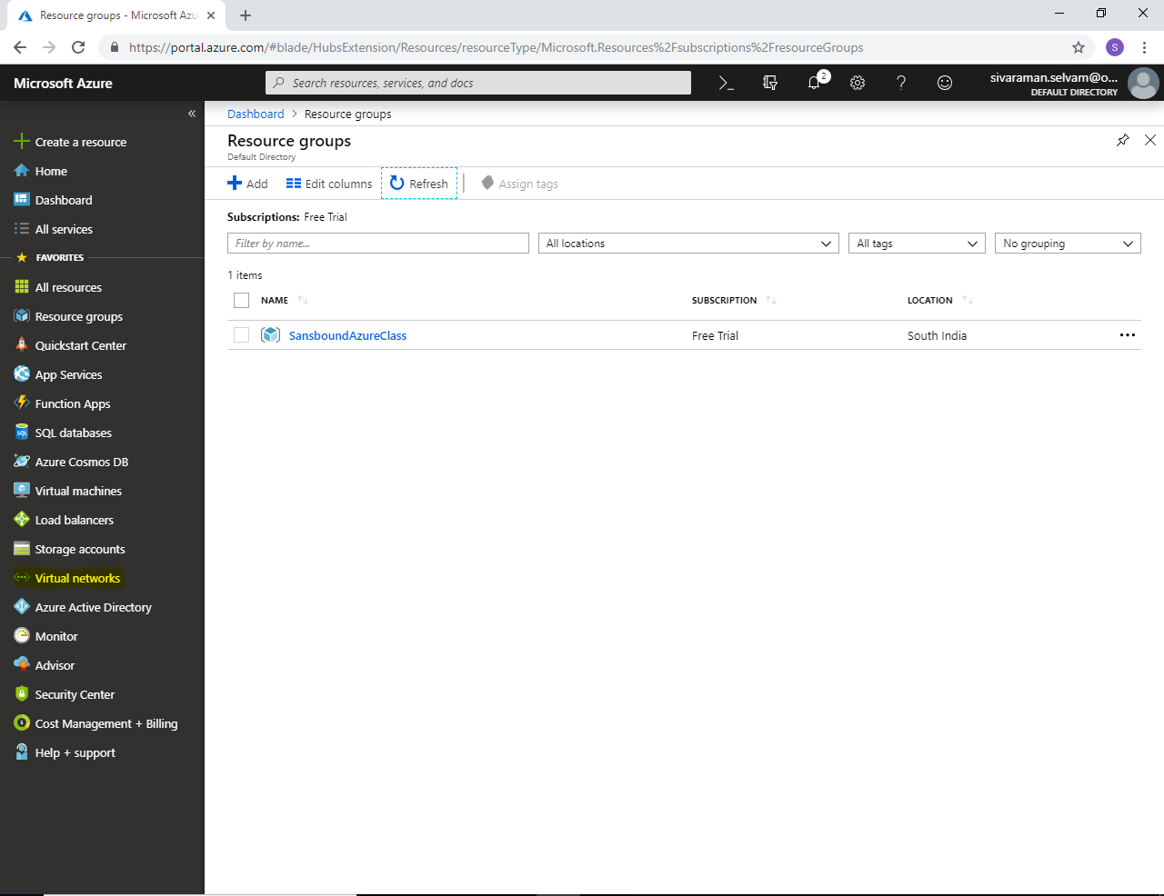

In **“Virtual networks”**

Click **“Add”**.

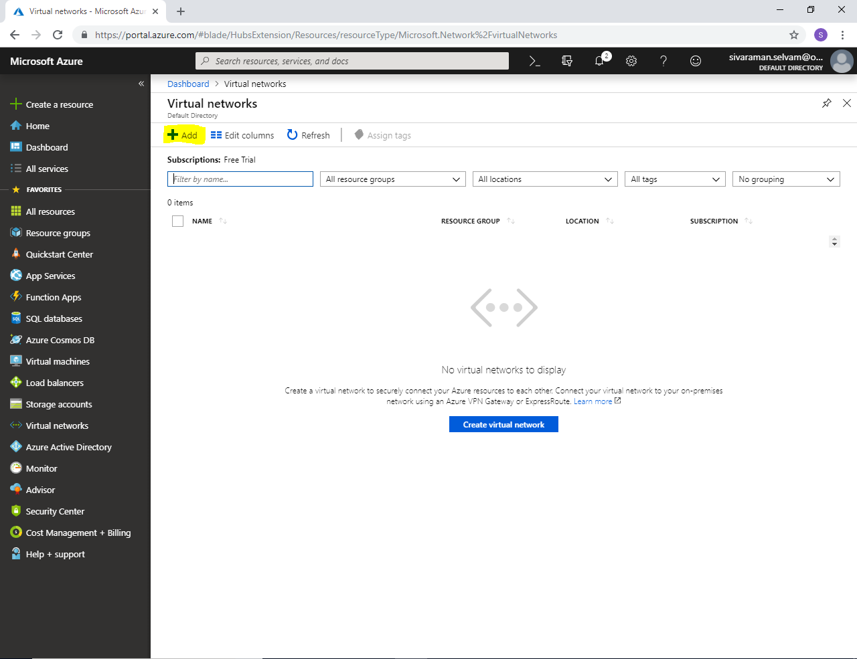

While creating **“Virtual network”**.

Type **“Virtual Network name”** as **“SANS-VNET”**.

In **“Address range”** as **10.0.0.0/16.**

Select **“Subscription”** as **“Free Trial”**.

Select **“Resource group”** as **“SansboundAzureClass”**.

Select **“Region”** as **“South India”**.

In **“Subnet”** type the name of the Subnet as **“Sans-Pub-Subnet”**.

In **Subnet “Address range”** type as **10.0.1.0/24**.

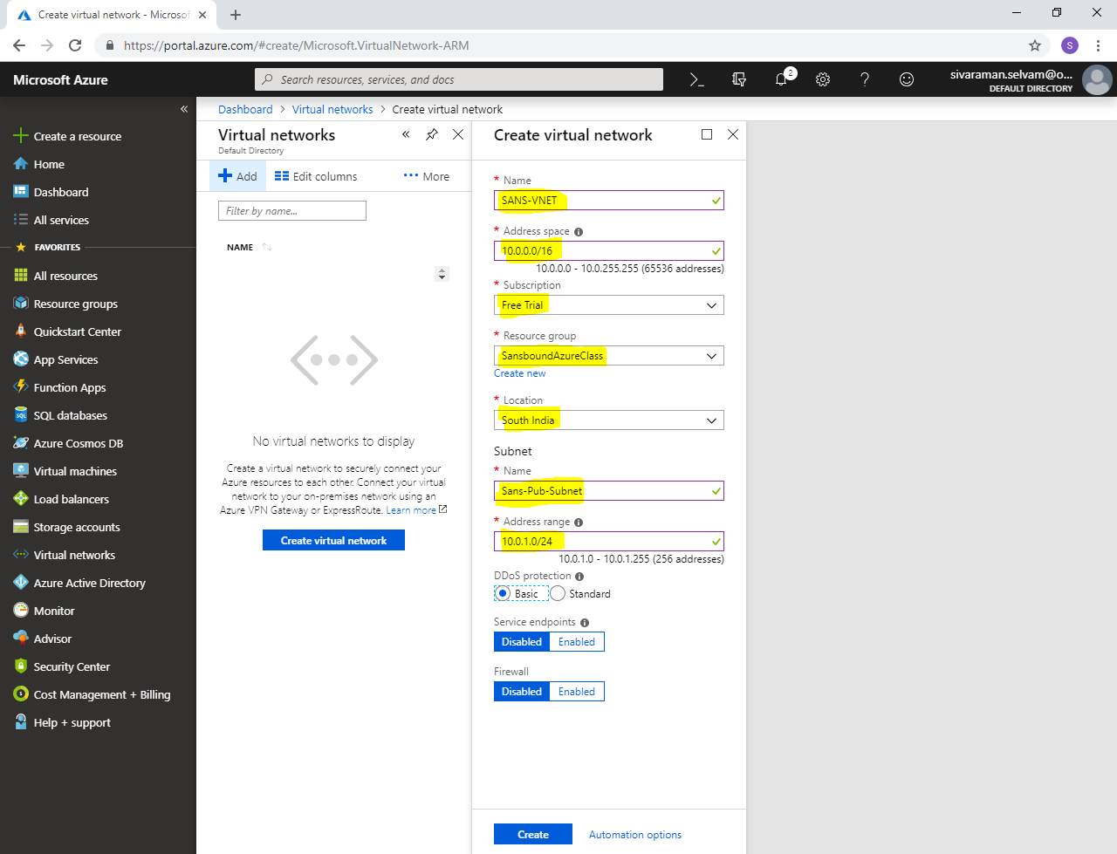

Click **“Create”**.

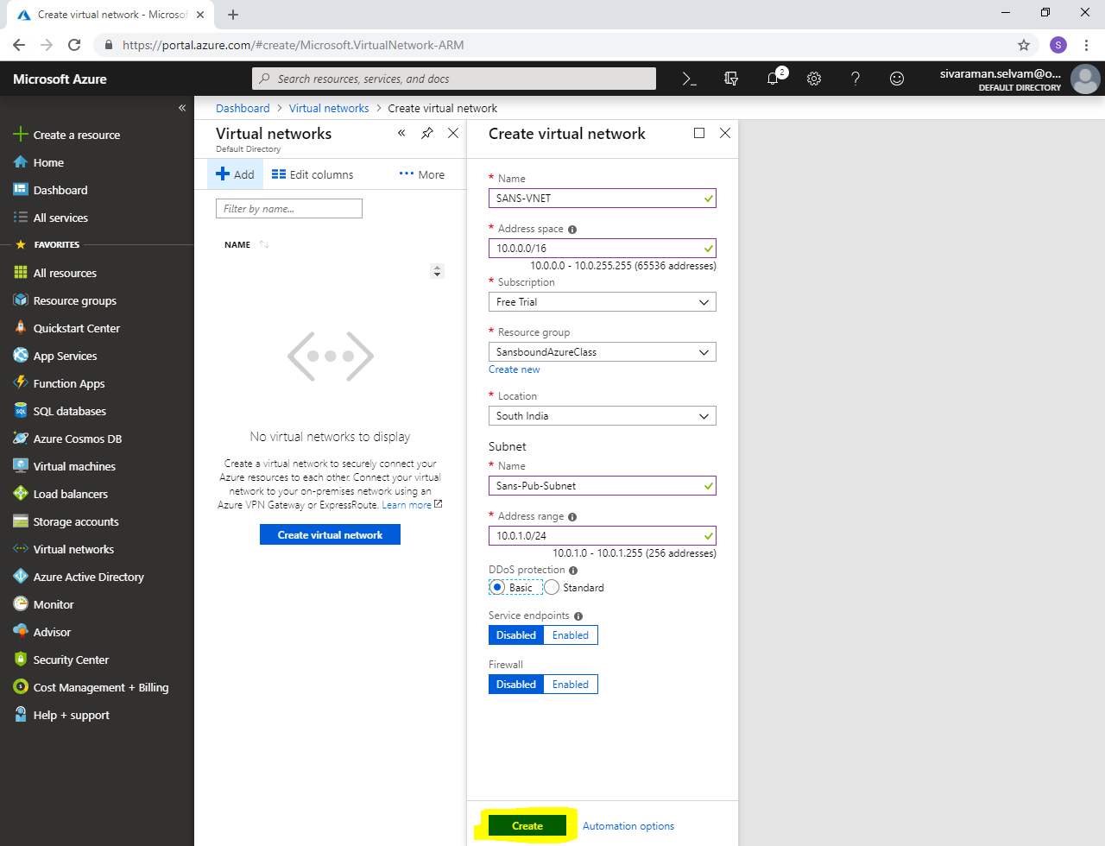

Click **“Virtual machines”** in left side panel.

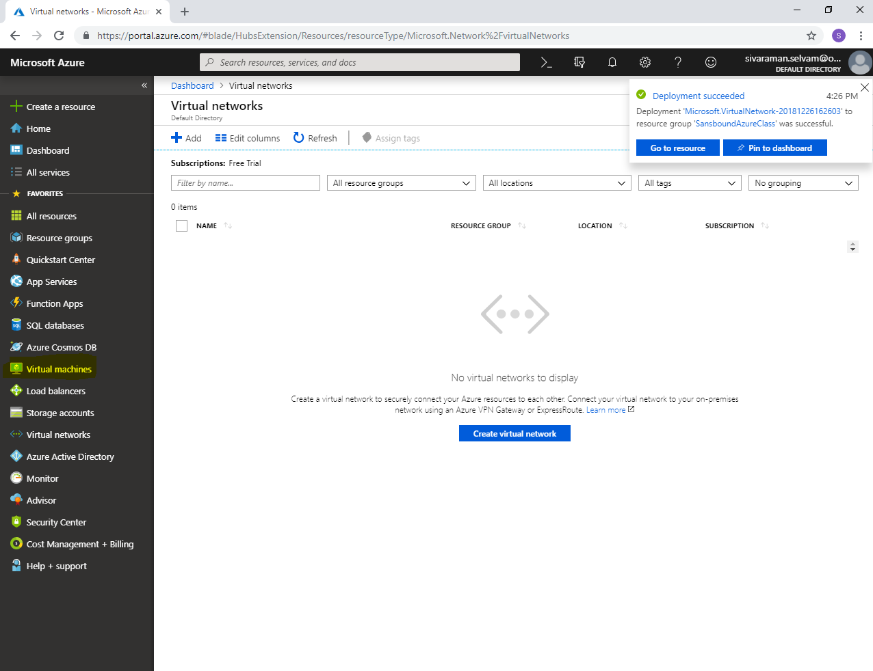

In **“Virtual machines”**.

Click **“Add”** to create Virtual machine.

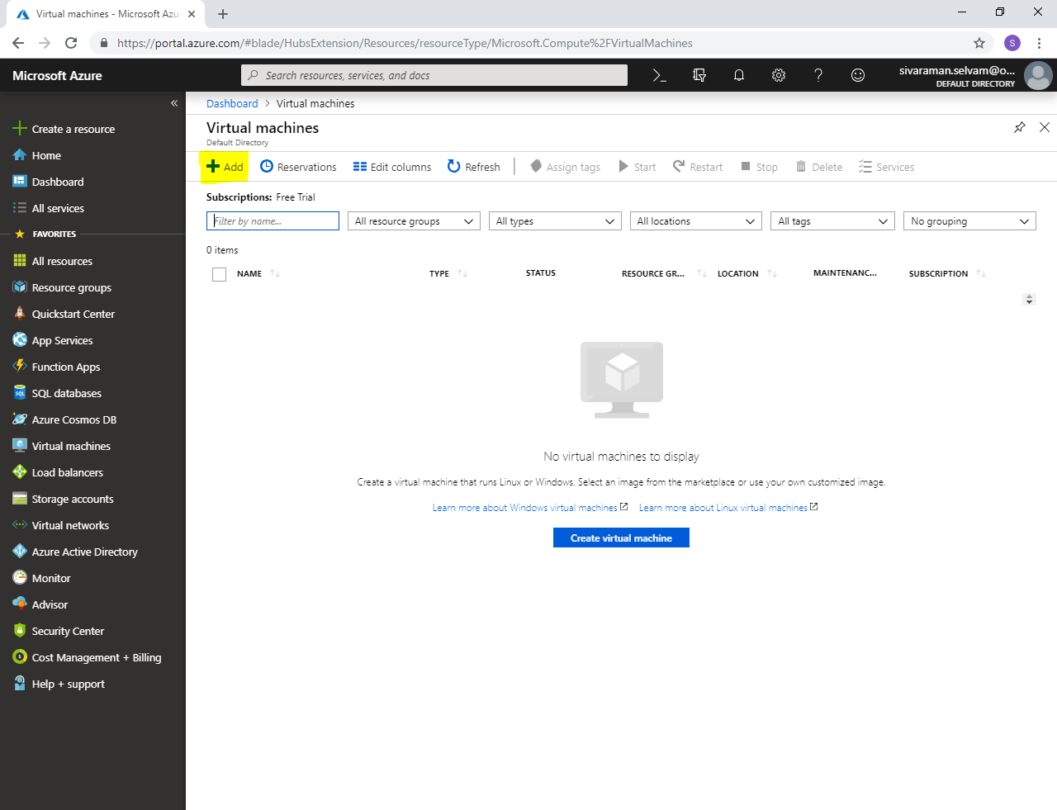

While creating **“Virtual machine”**

Select **“Subscription”** as **“Free Trial”**.

Select **“Resource Group”** as **“SansboundAzureClass”**.

In **“Virtual machine name”** type **“Ubuntu-AzureVM”**.

Select **“Region”** as **“South India”**.

Select **“Image”** as **“Ubuntu Server 18.04 LTS”**.

Change **“VM Size”** as **“Standard B1s”**

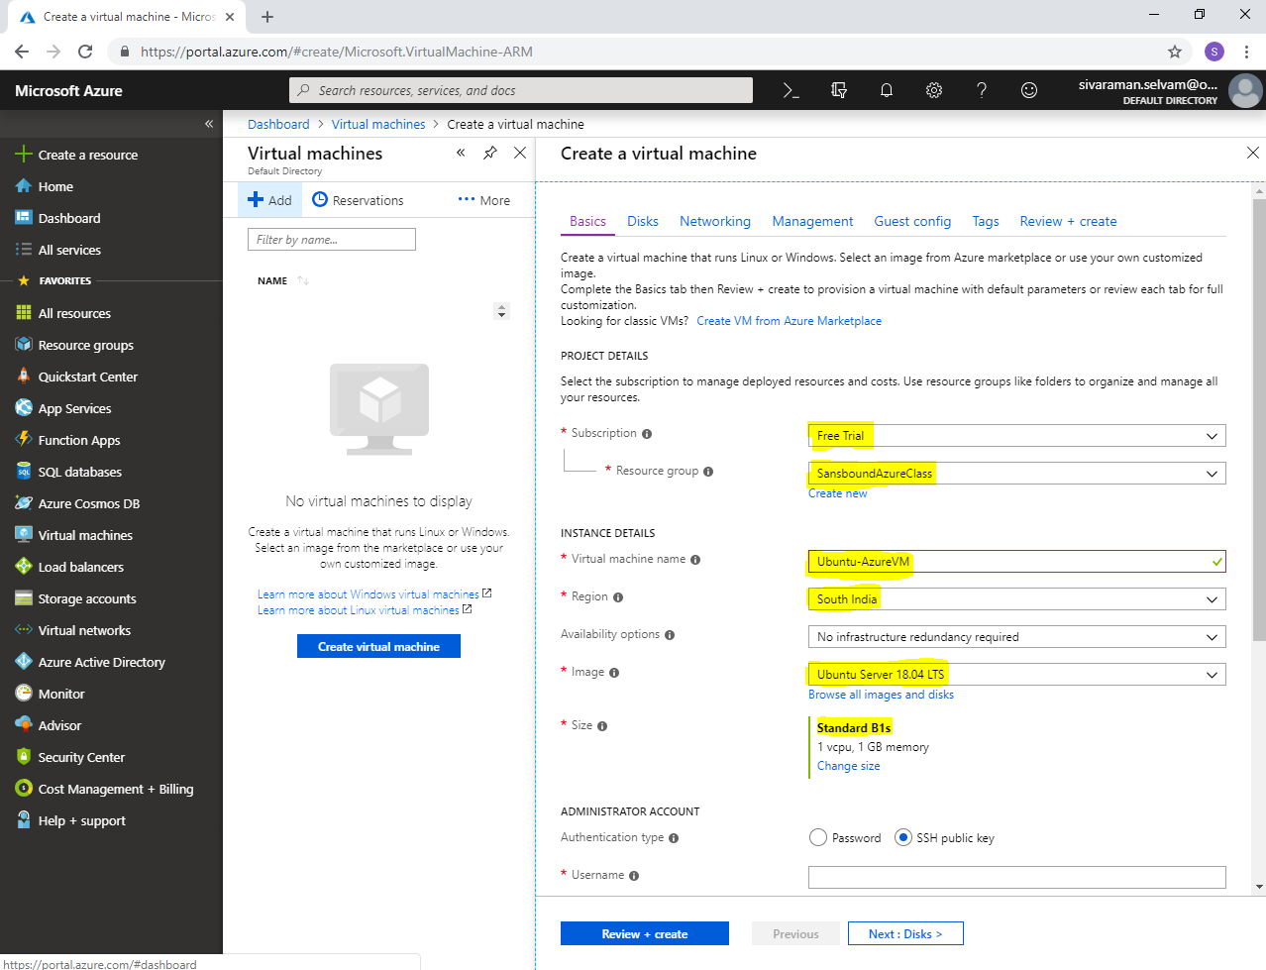

In **“Administrator Account”**

Set **“Authentication type”** as “**Password”**.

In **“Username”** type as **“sansbound”**.

In Password type the password for the Ubuntu server to access through SSH.

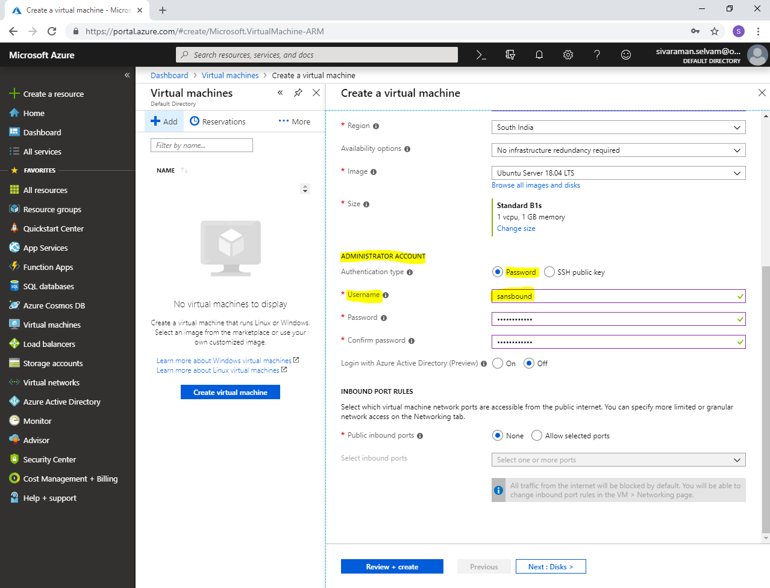

In **“Inbound Port Rules”**

Set **“Public inbound ports”** as **“Allow selected ports”**.

Select **“Select inbound ports”** as **“SSH”** and **“HTTP”** Ports.

Because I am going to install apache web server in Ubuntu and capture the Ubuntu VM as Image, then build a new VM with customized or captured image.

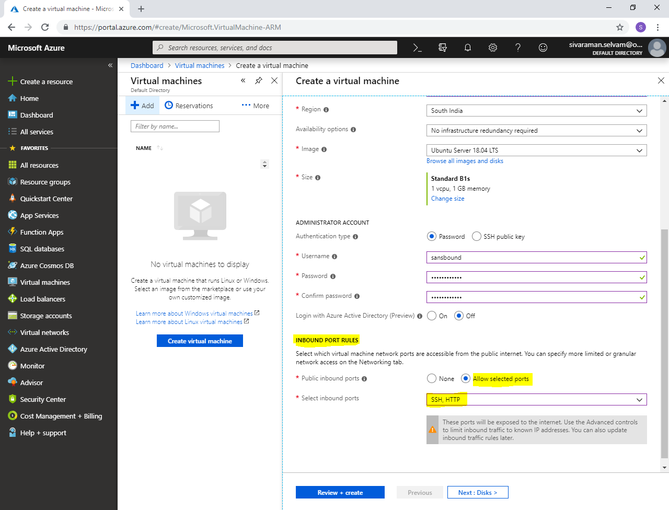

Click **“Next : Disks >”**.

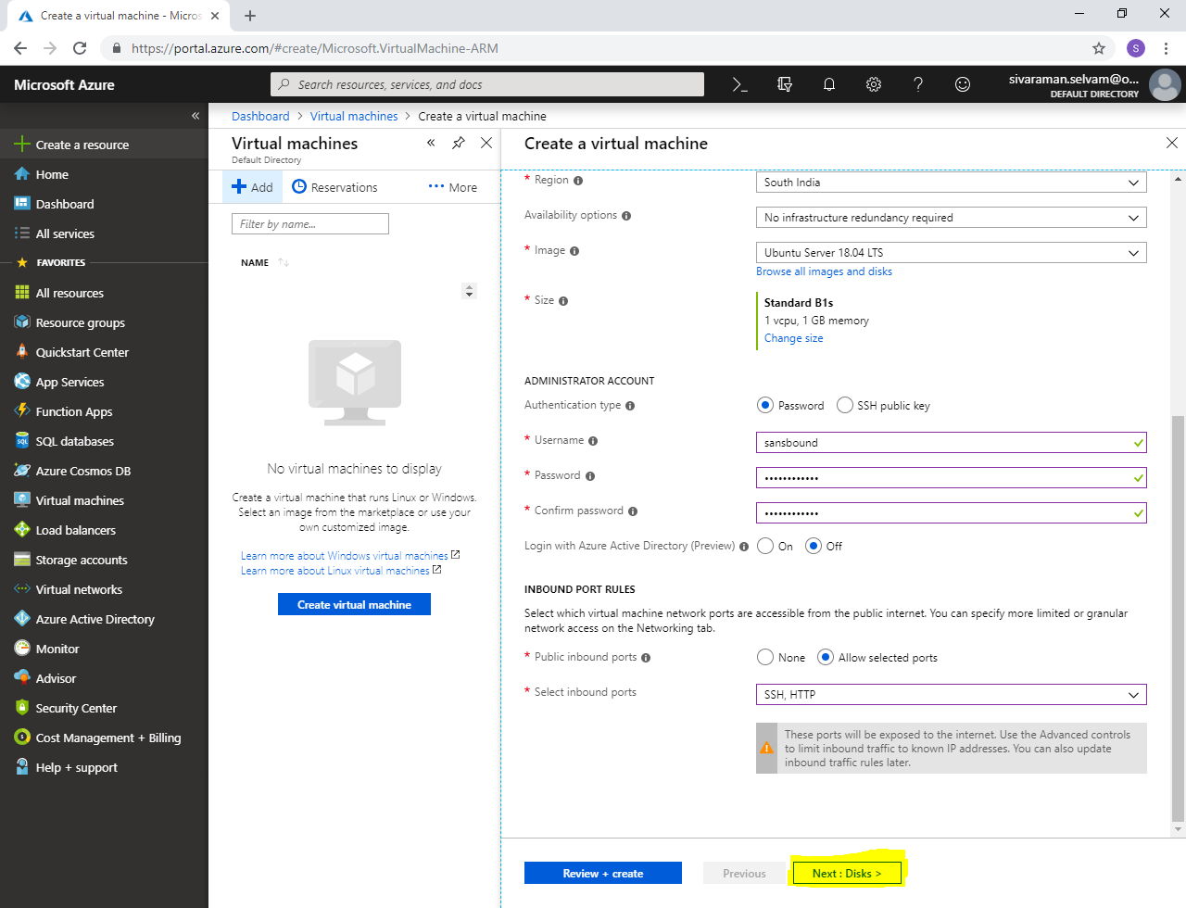

In **“Disks”**

Ensure that you have selected “Managed disks”.

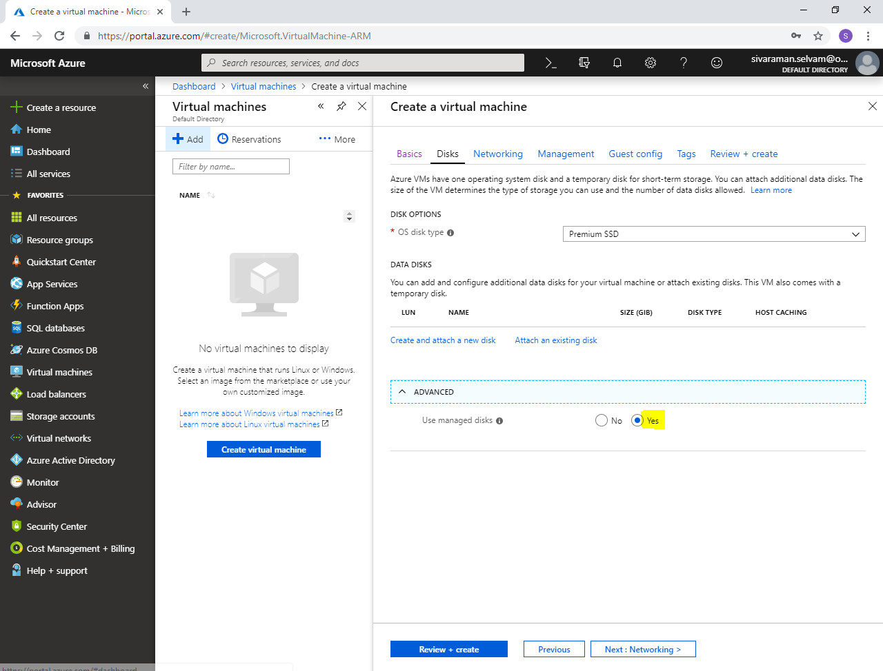

Click **“Next : Networking >”**.

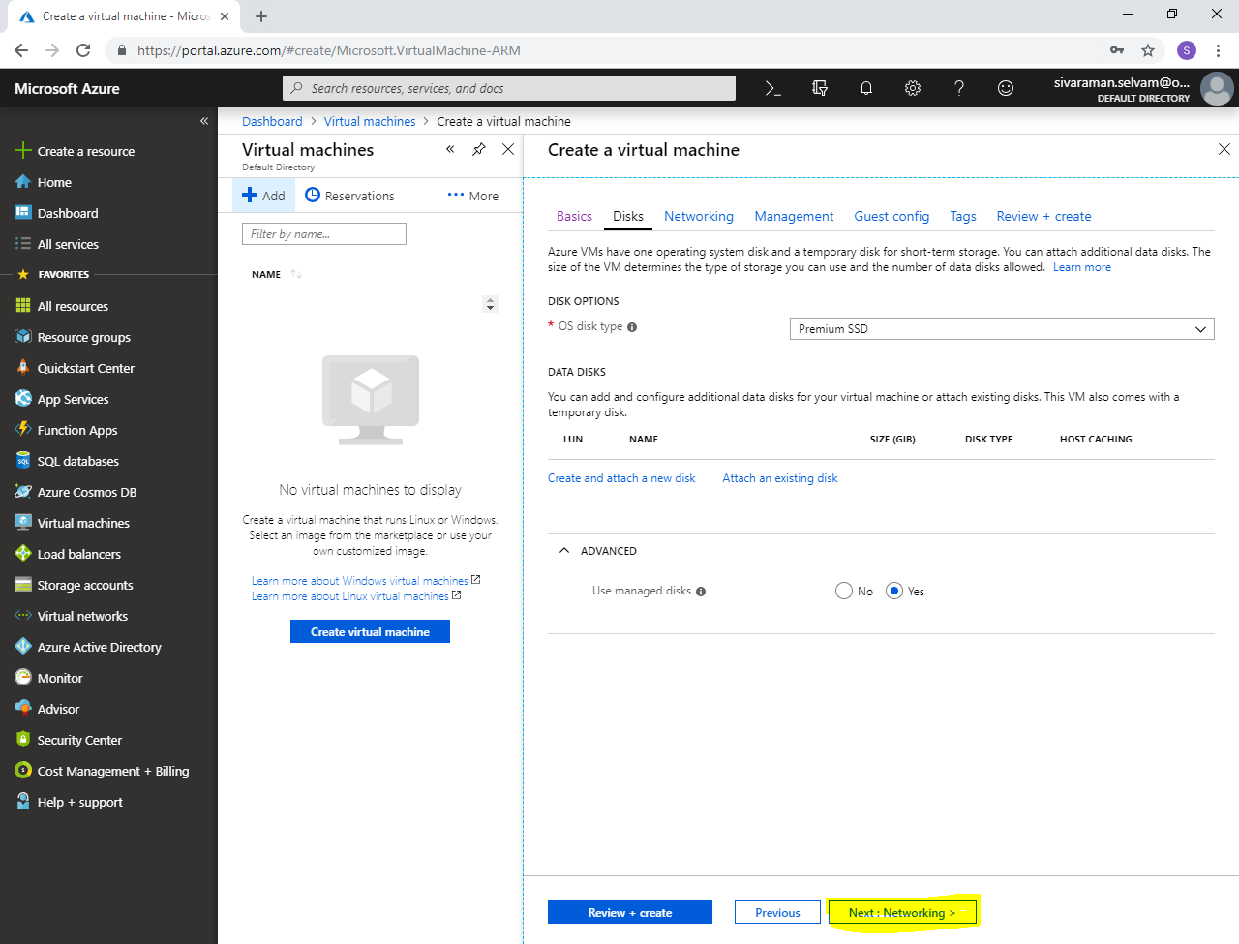

In **“Networking”**

Ensure that **“Virtual network”** as **“SANS-VNET”**.

Ensure that **“Subnet”** as **“Sans-Pub-Subnet”** as **10.0.1.0/24**

Public IP for Ubuntu-AzureVM.

Ensure **“Network Security Group”** as **“Basic” / “Advanced”**.

In **“Public inbound ports”** as **“Allow selected ports”**.

Ensure **“Select inbound ports”** as **“SSH”** and **“HTTP”** are allowed.

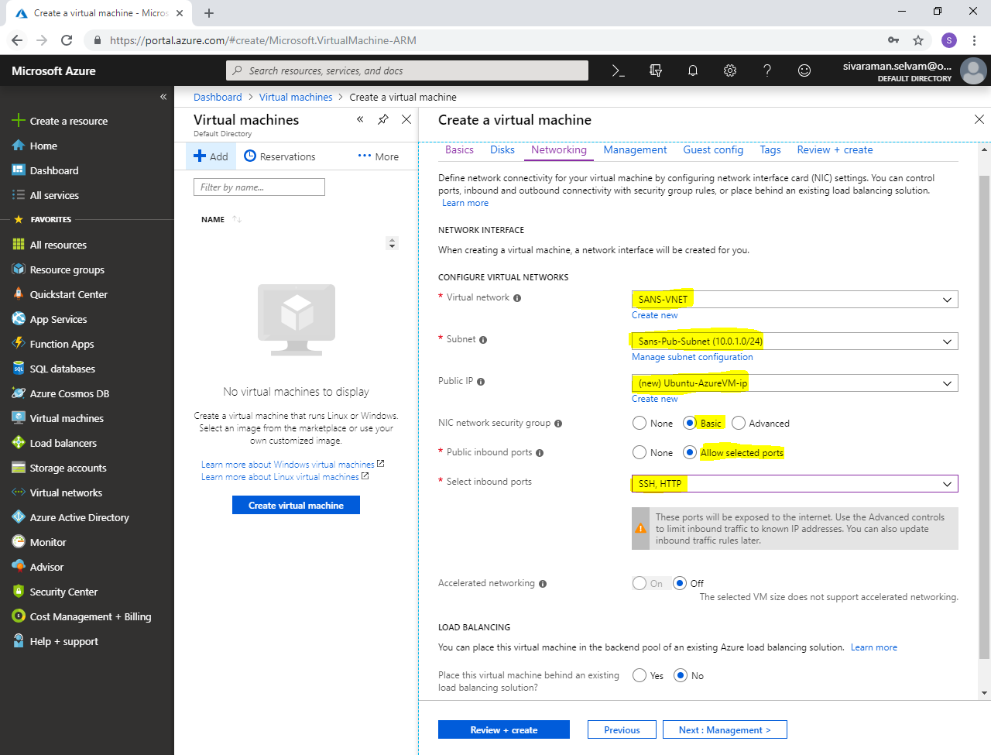

Click **“Next : Management >”**.

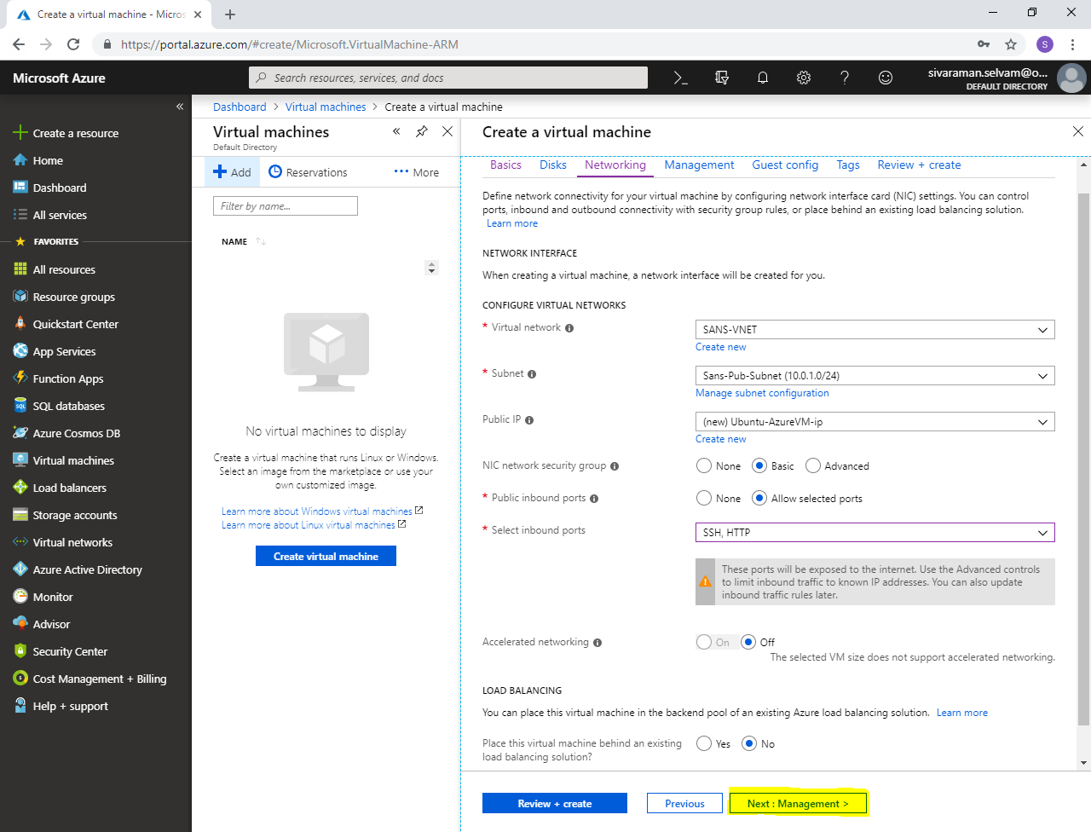

In **“Management”**

Click **“Next : Guest config >”**.

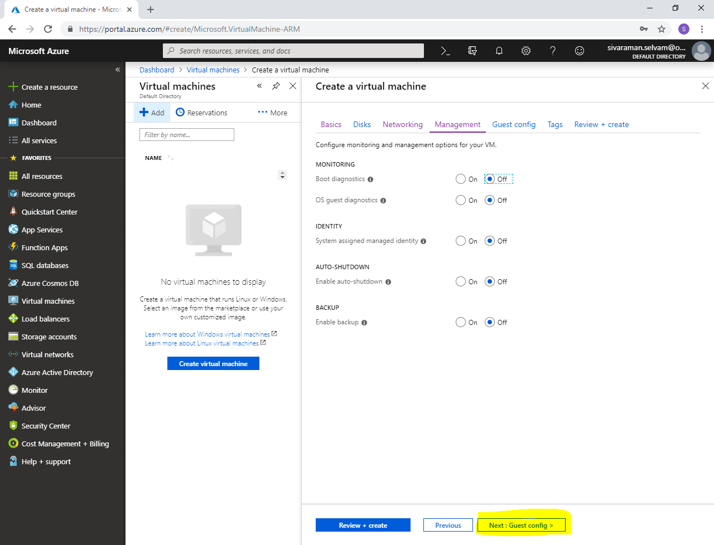

In **“Guest config”**.

Click **“Next : Tags >”**.

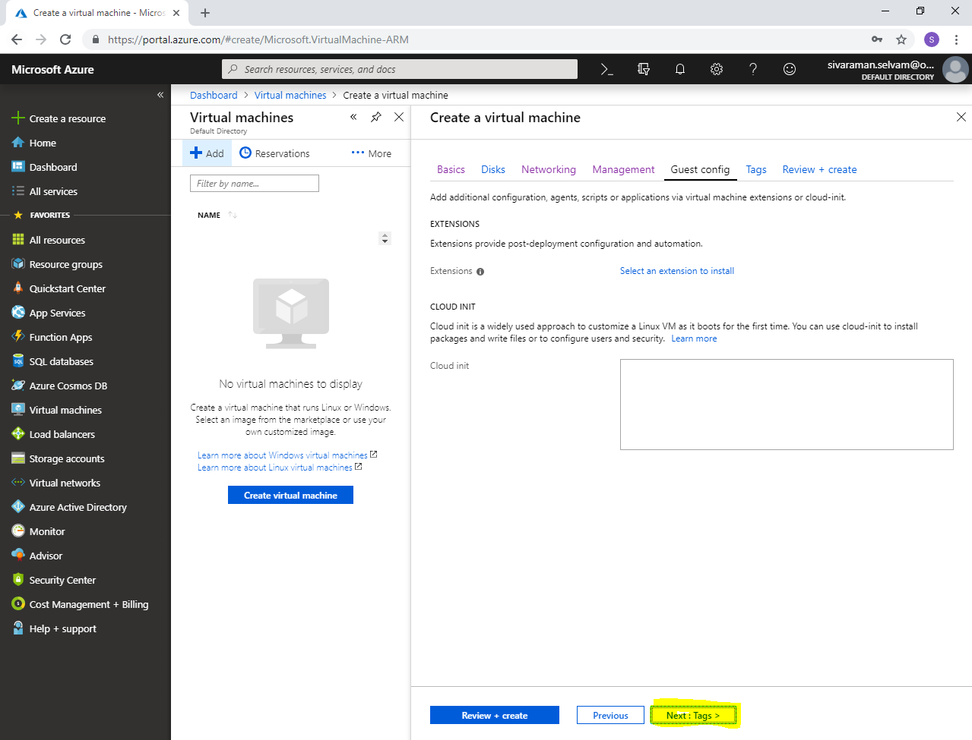

Click **“Review + create”**.

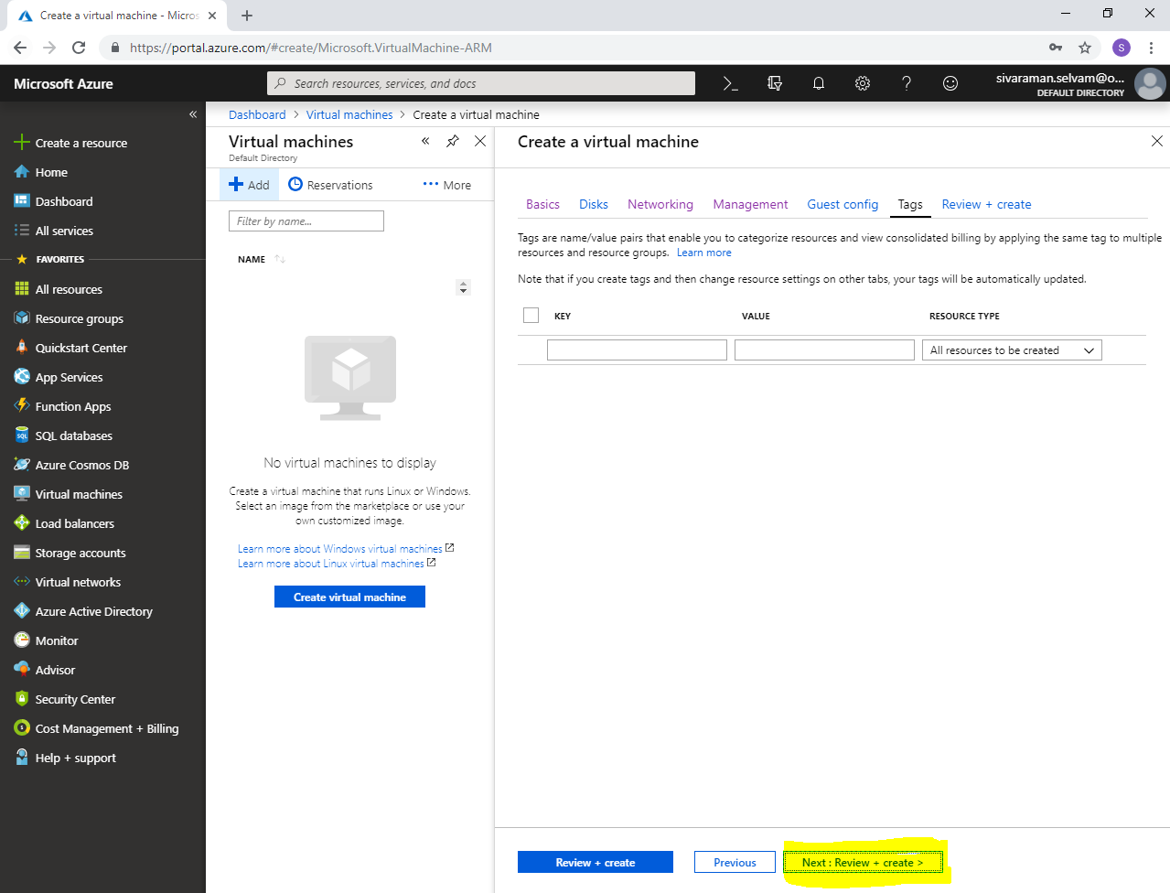

Click **“Create”**.

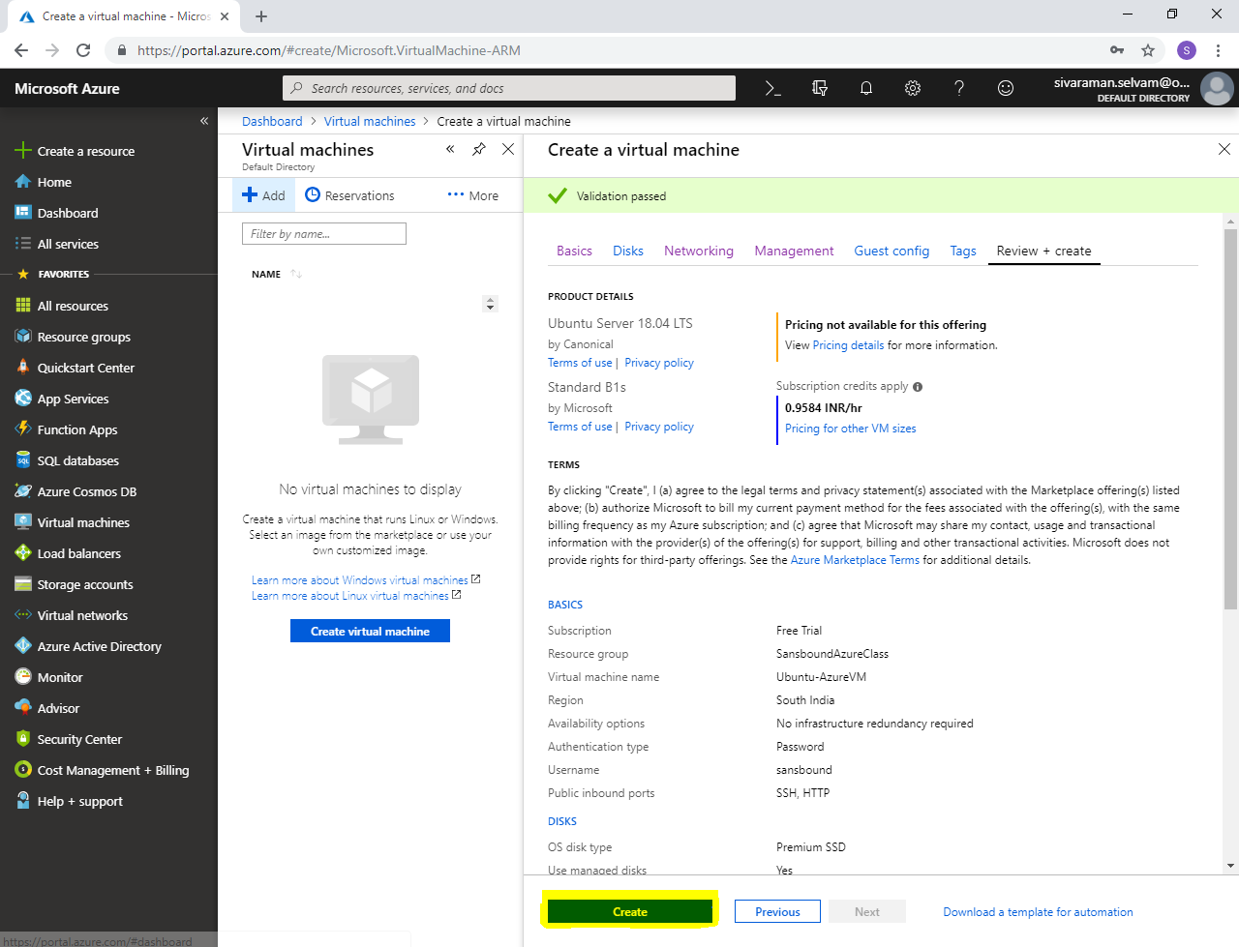

Click **“Go to resource”**.

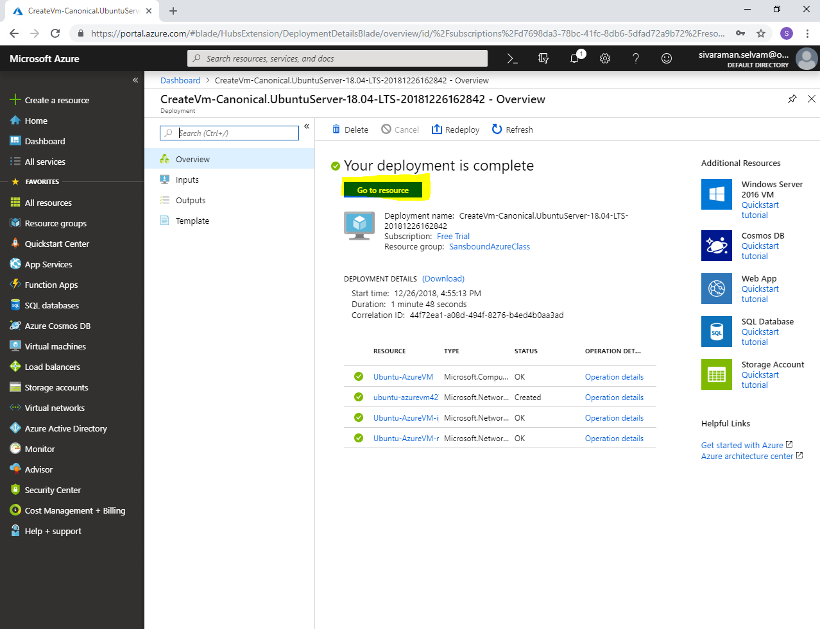

Kindly note the public address, we have required to access Ubuntu VM by using this IP only.

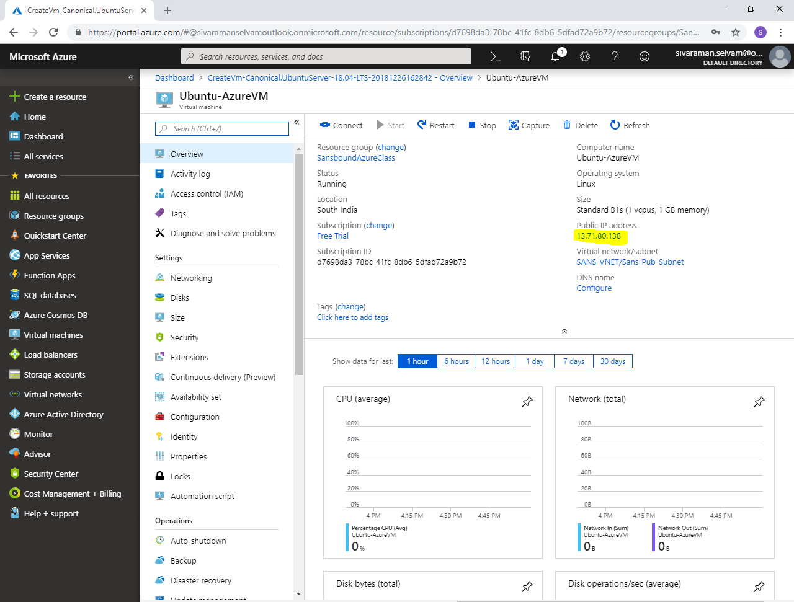

Need to launch “Putty”.exe” from local machine and type the IP address of Ubuntu VM in Putty.

Click **“Open”** to connect Ubuntu server through SSH.

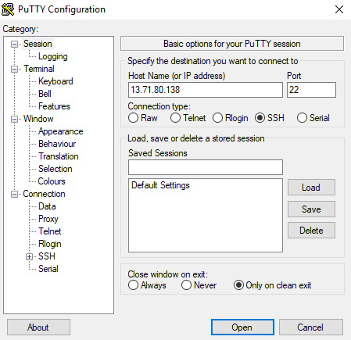

Click **“Yes”**.

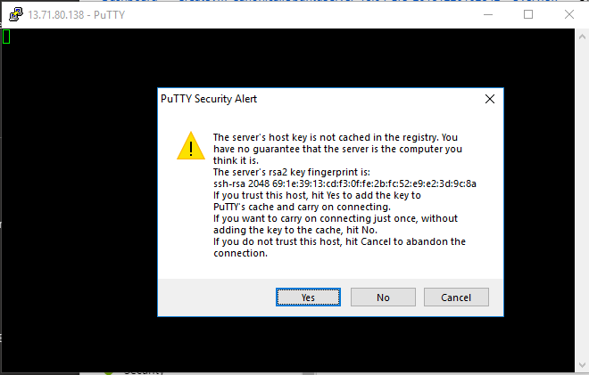

Type **username** of Ubuntu as “sansbound” and press **“Enter”.**

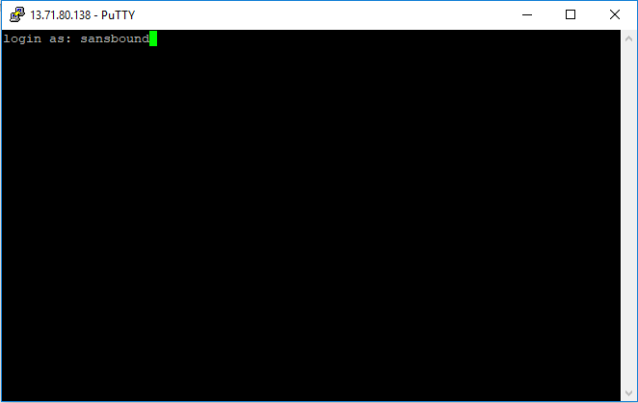

Type **Password** for the Ubuntu server and press **“Enter”**

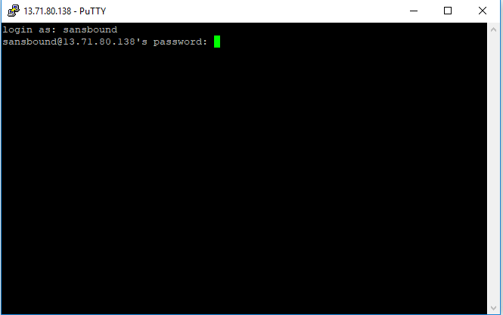

Now you have successfully logged into Ubuntu server.

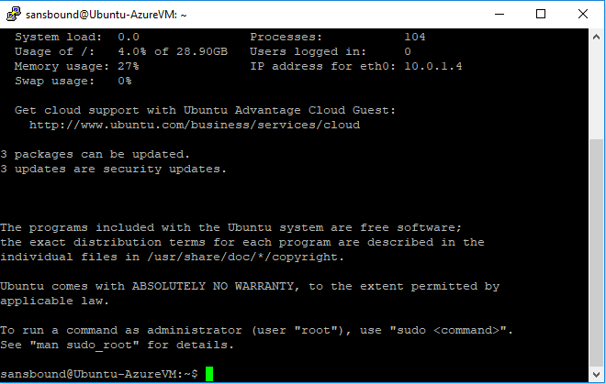

Now I have required to login as root user account.

Type **“sudo –i”** and press **“Enter”**.

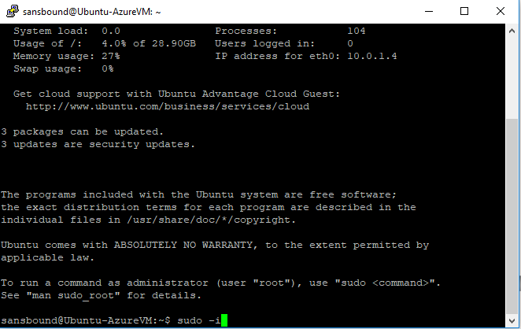

Now you have successfully logged as a root user.

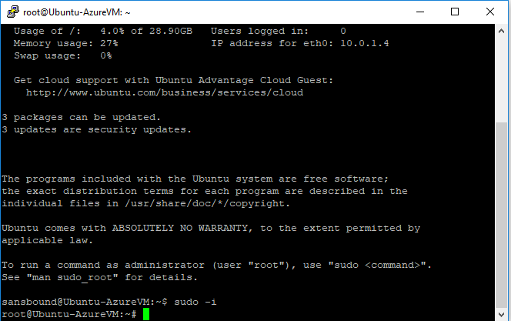

Now I have required to update packages.

Type **“apt-get –y update”** and press **“Enter”**.

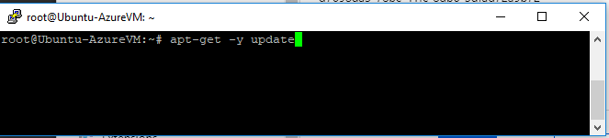

Packages are successfully updated.

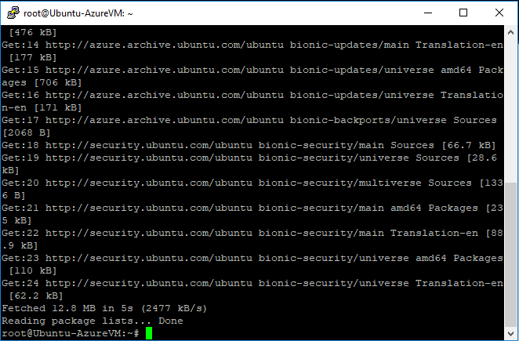

Now we have required installing Apache in Ubuntu VM.

Type **“apt-get install apache2”** and press **“Enter”**.

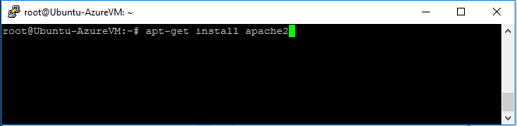

Type **“y”** and press **“Enter”** to install the package.

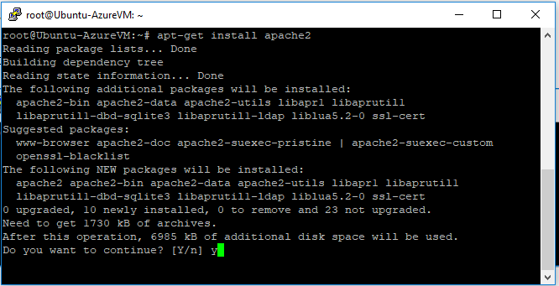

We have successfully installed Apache in Ubuntu.

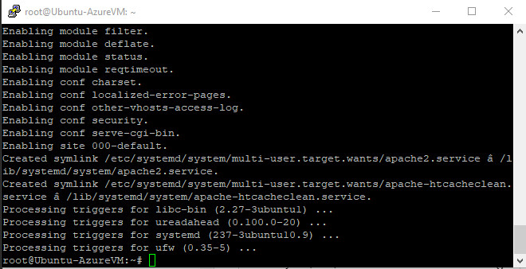

I have required customizing the default webpage.

Type **“vi /var/www/html/index.html”** and press **“Enter”**.

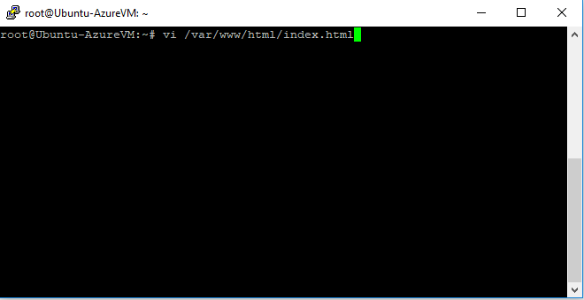

Go to **Line number “198”**, then we have required to delete existing content and replace it as our own wish.

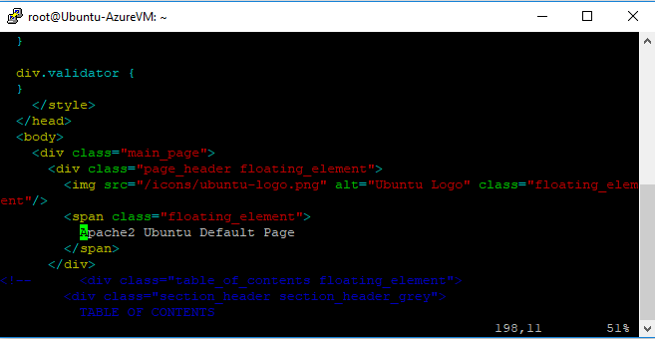

Delete the previous content

Then press **“Insert”** key

Type our content as **“Sansbound Azure Class Page”**.

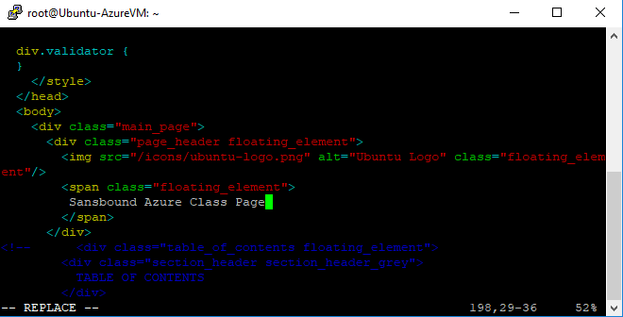

Press **“Escape”** key

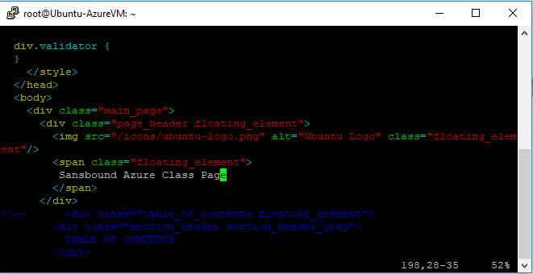

Then type in bottom line **“:wq”** and press **“Enter”** to save the file.

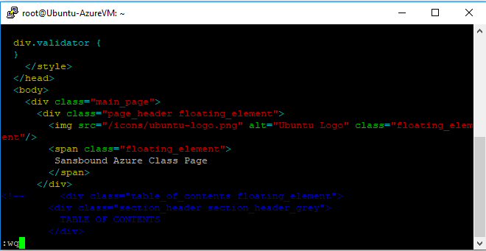

Type public IP address of the Ubuntu in browser and then press “Enter”.

Now you have got the customized web page named as **“Sansbound Azure Class Page”**.

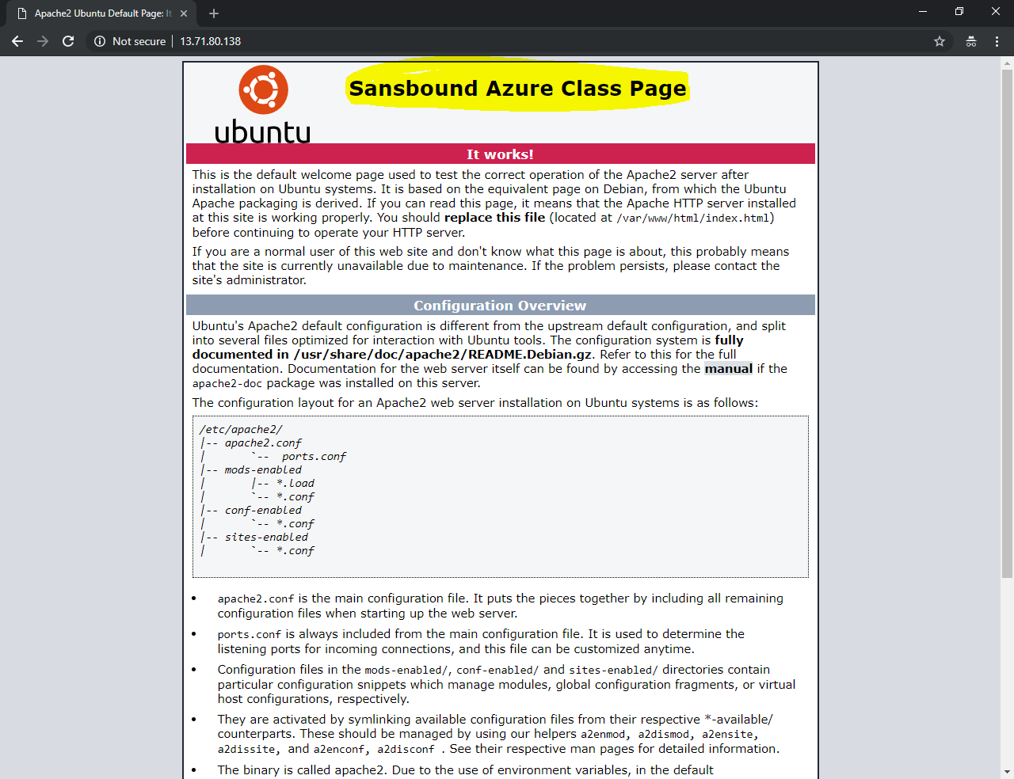

Now we have required to **“Capture”** the existing Ubuntu Virtual machine.

In **“Virtual machines”**

Click **“Ubuntu-AzureVM”**.

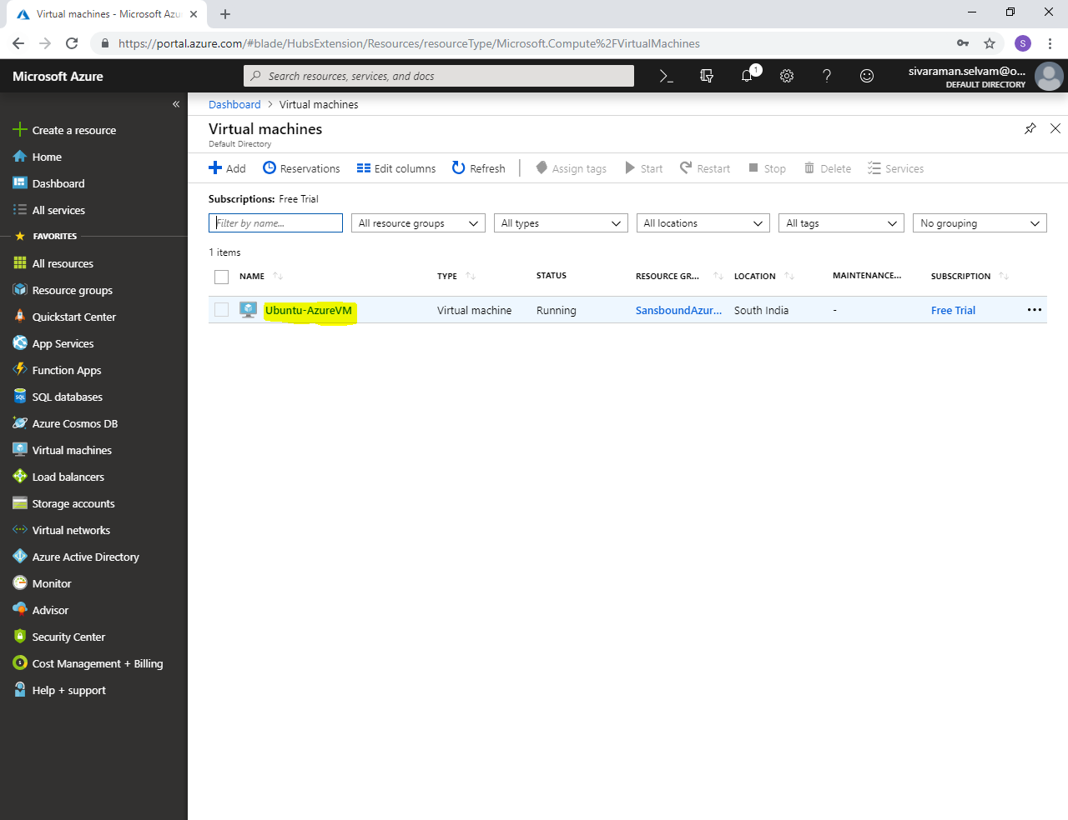

In **“Ubuntu-AzureVM”** you are able see that **“Capture”** option is available to capture the Virtual Machine as **“Image”**. **This feature is only available in Managed disks only.**

Click **“Capture”**.

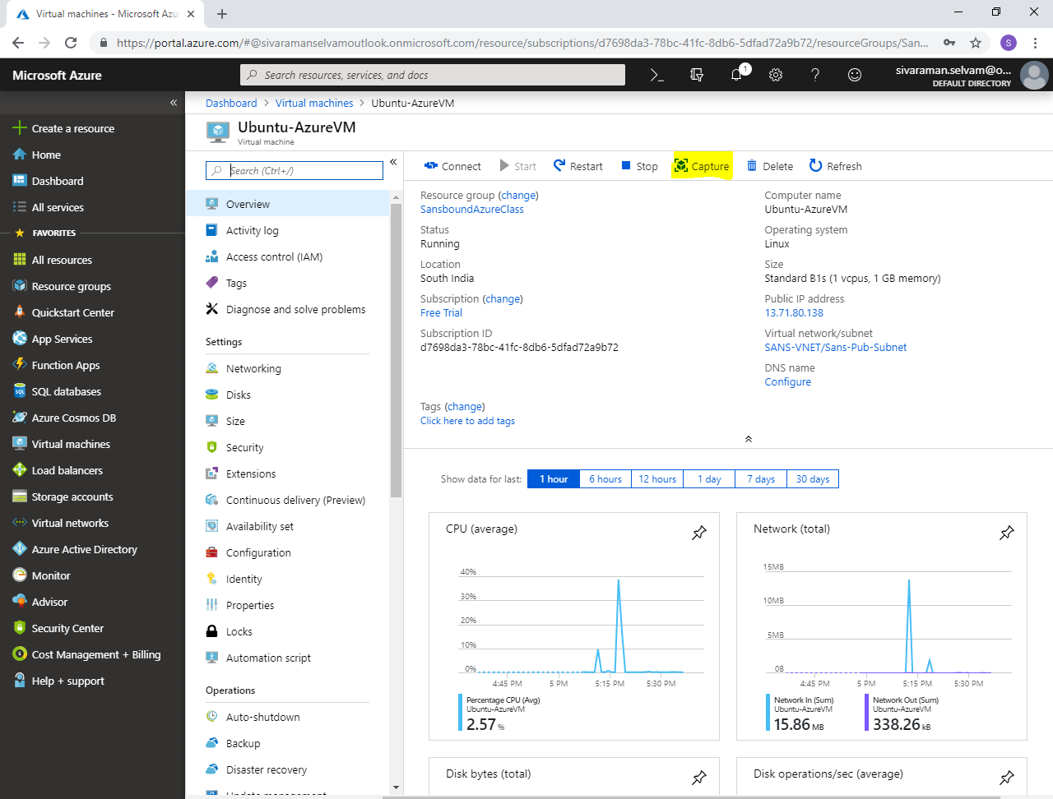

While try to create **“Image”** it shows are warning message to complete prerequisite to run below mentioned command in Ubuntu

**“waagent –deprovision+user”**

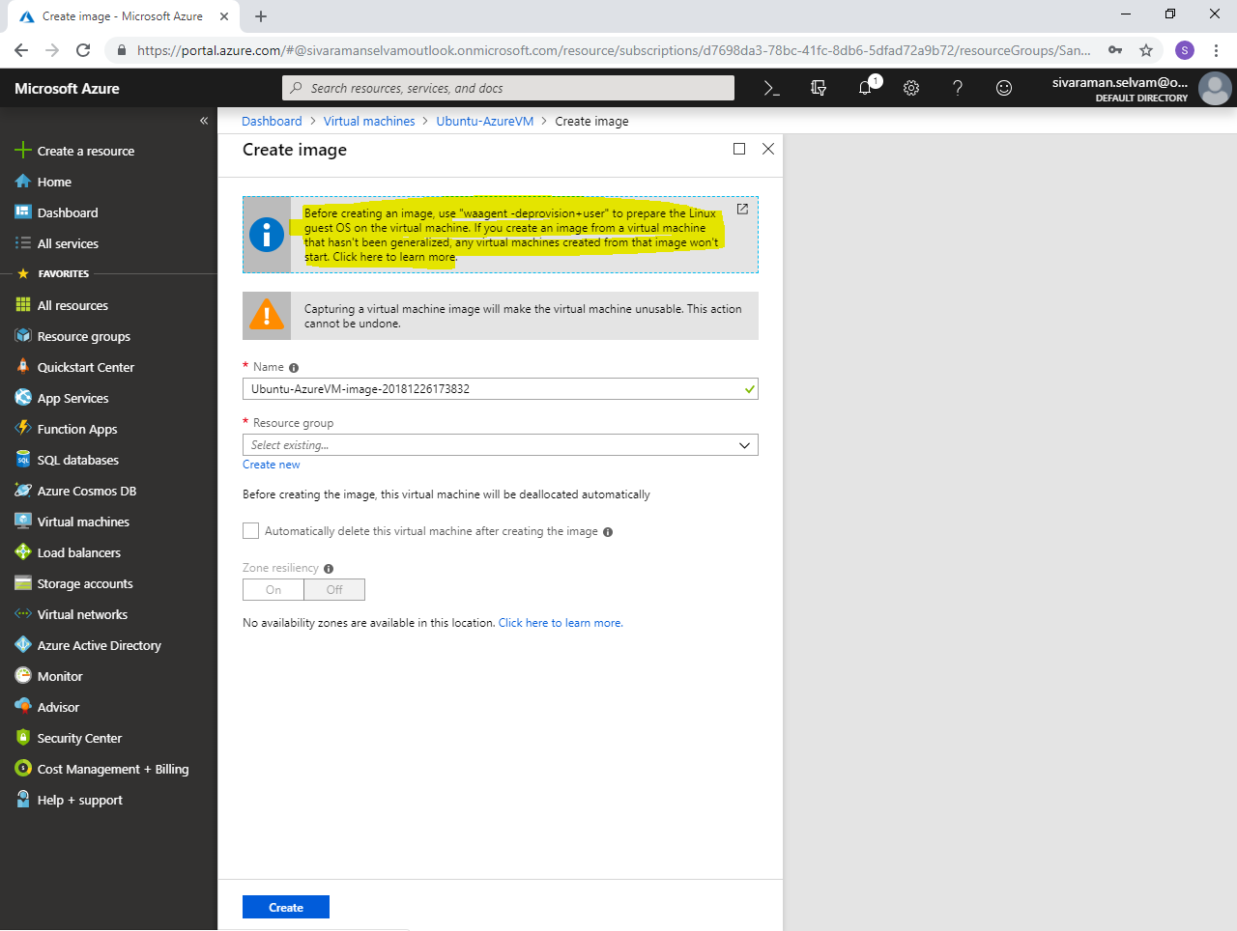

In Ubuntu machine,

Type **“waagent –deprovision+user”** and press **“Enter”**.

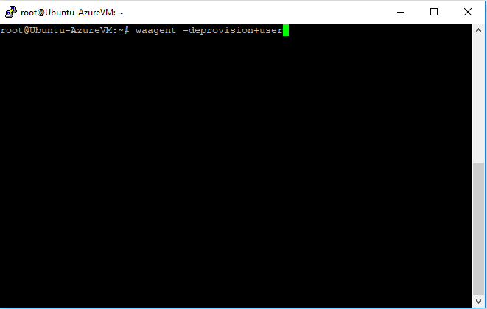

**Data in entire home directory will be deleted.**

Press **“y”** and press **“Enter”** to delete the home directory data.

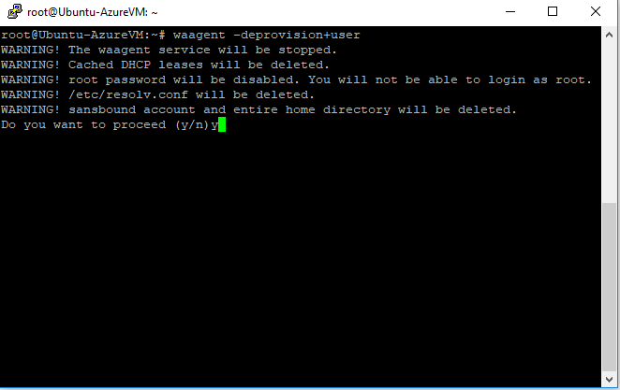

Select **“Ubuntu-AzureVM”** and click **“Stop”**.

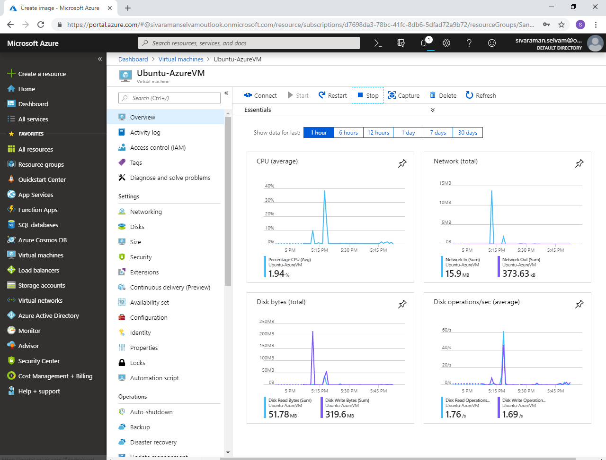

In **“Ubuntu-AzureVM”**.

Ensure that **“Ubuntu-AzureVM”** is in stopped state.

Click **“Capture”** to capture the Virtual machine.

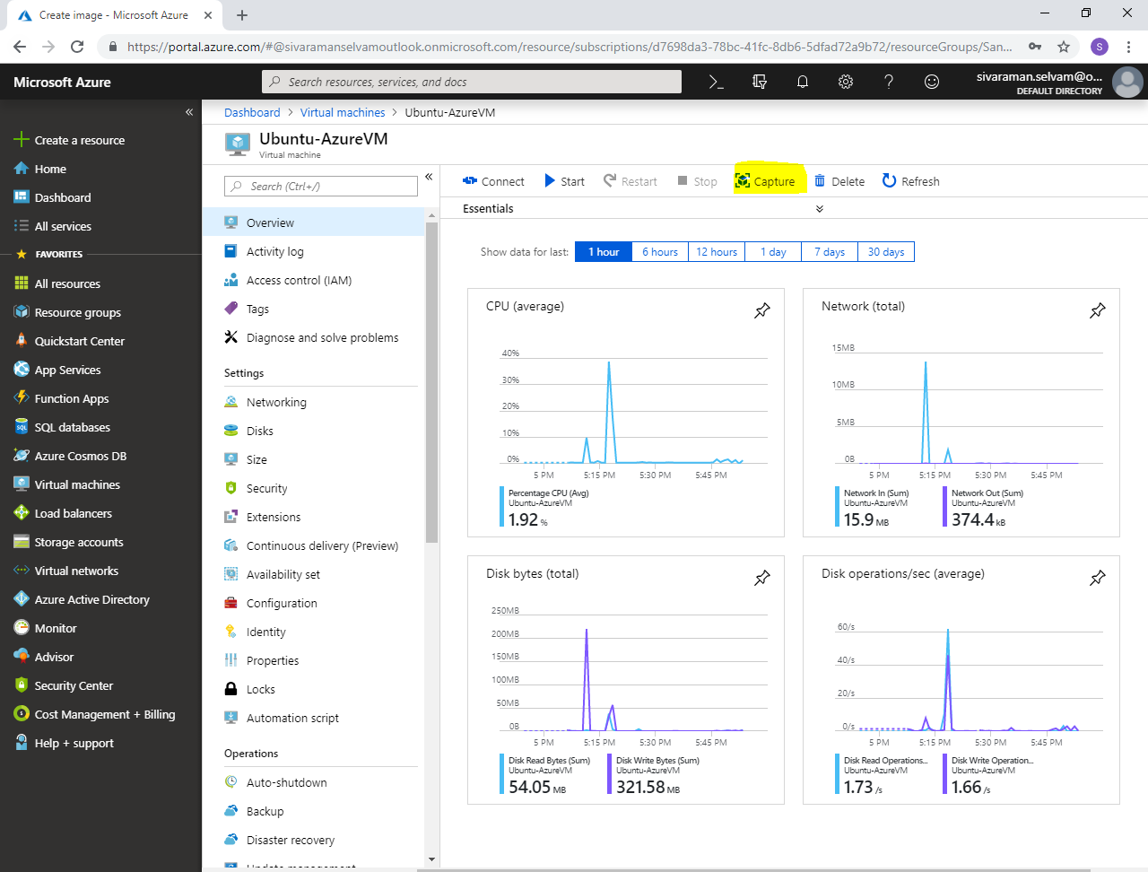

Type the **Image name** as **“Ubuntu-SansWebServer”**.

Select **“Resource group”** as **“SansboundAzureClass”**.

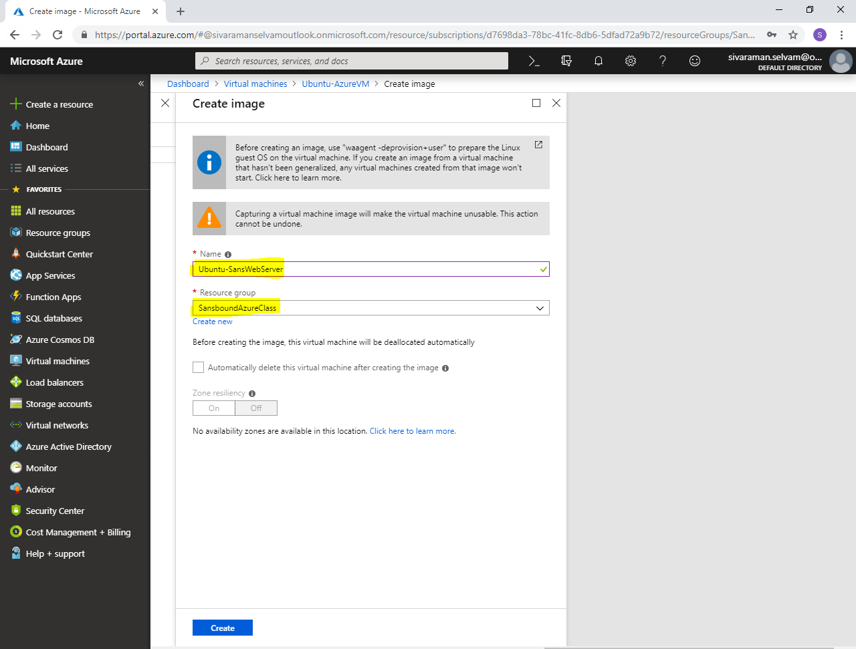

Click **“Create”**.

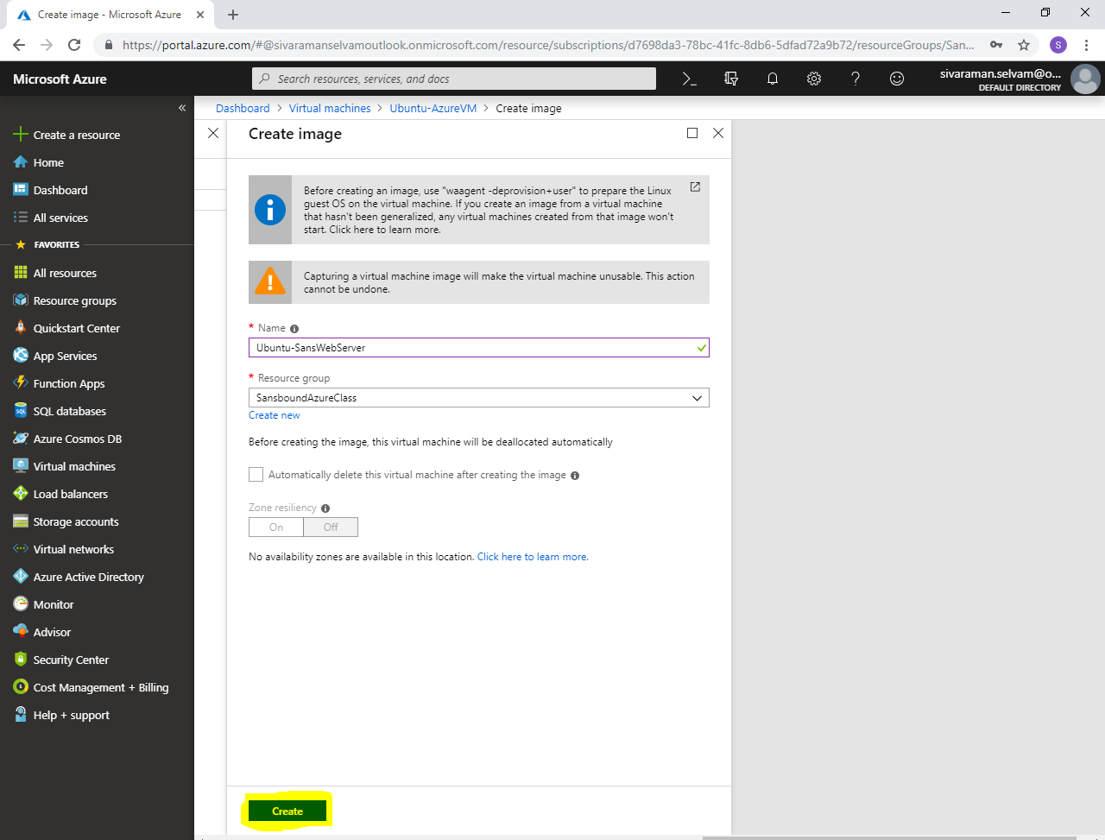

You will get a message once you have successfully captured the virtual machine.

Now, I have required to build a new virtual machine by using Captured image.

In **“Virtual machines”** click **“Add”** to create a new virtual machine.

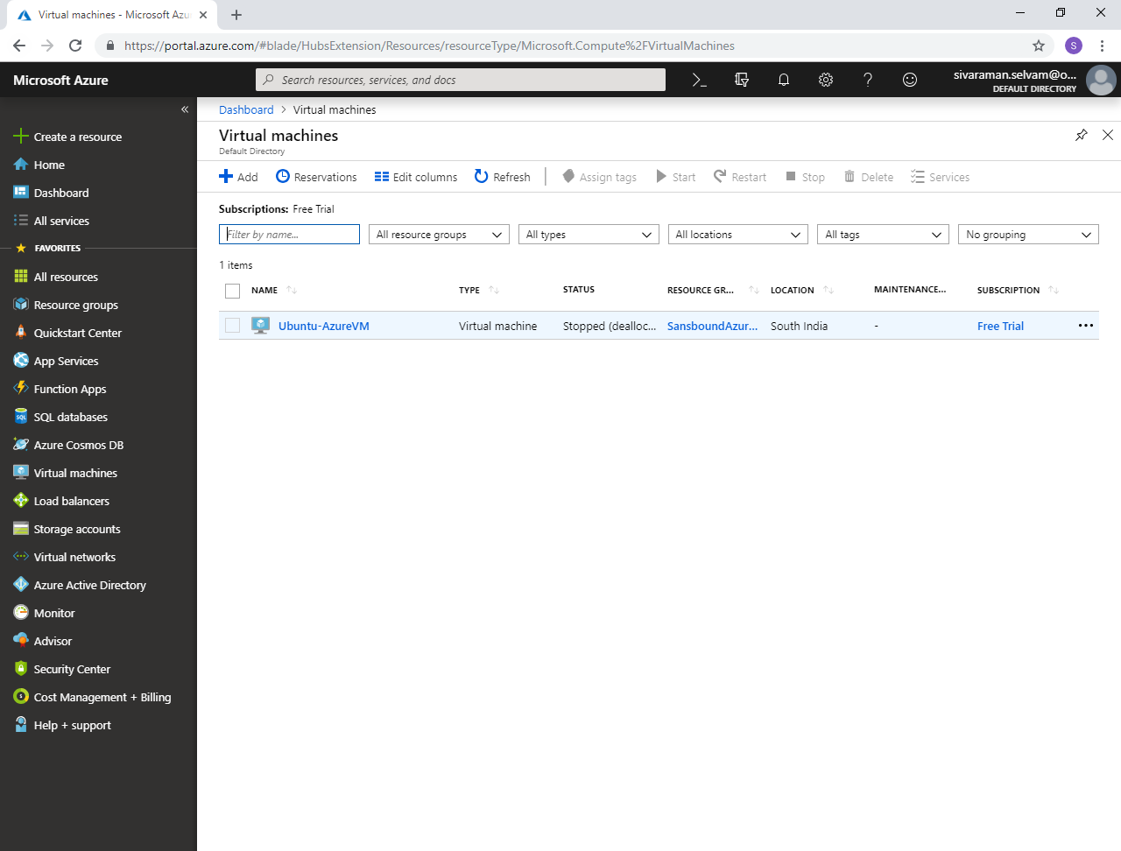

While creating Virtual machine,

Select **“Subscription”** as **“Free Trial”**.

Select **“Resource group”** as **“SansboundAzureClass”**.

In **“Virtual machine name”** type name as **“Ubuntu-SansWebSvr2”**.

Select **“Region”** as **“South India”**.

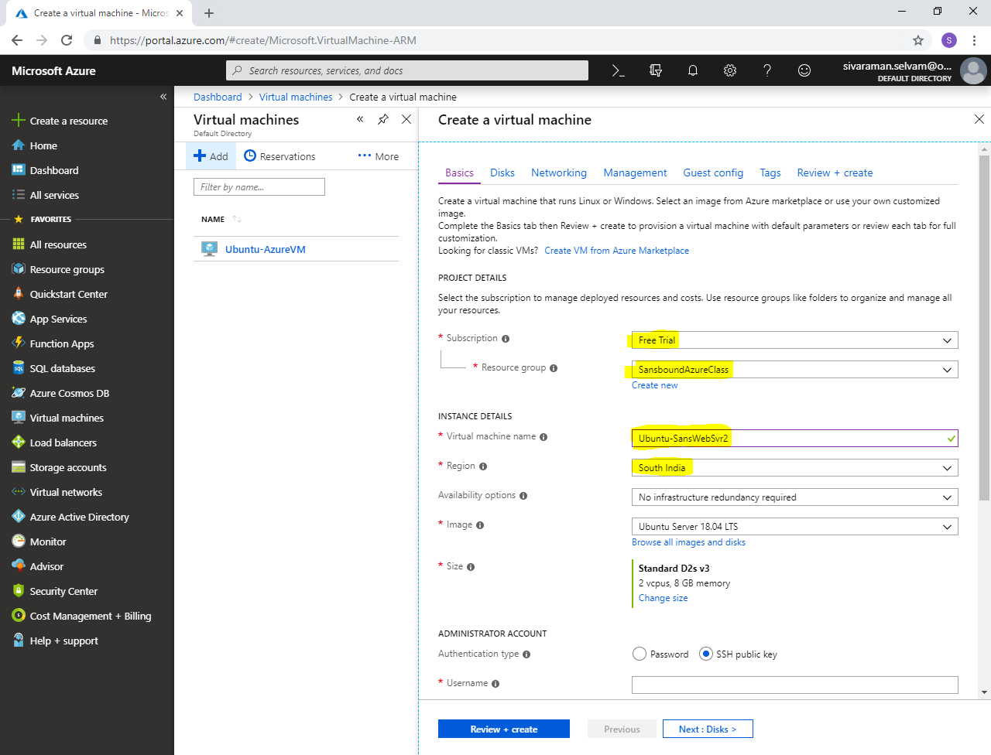

In **“Image”** you have required to select customized image which you have captured by using **Managed disks**. So click **“Browse all images and disks”**.

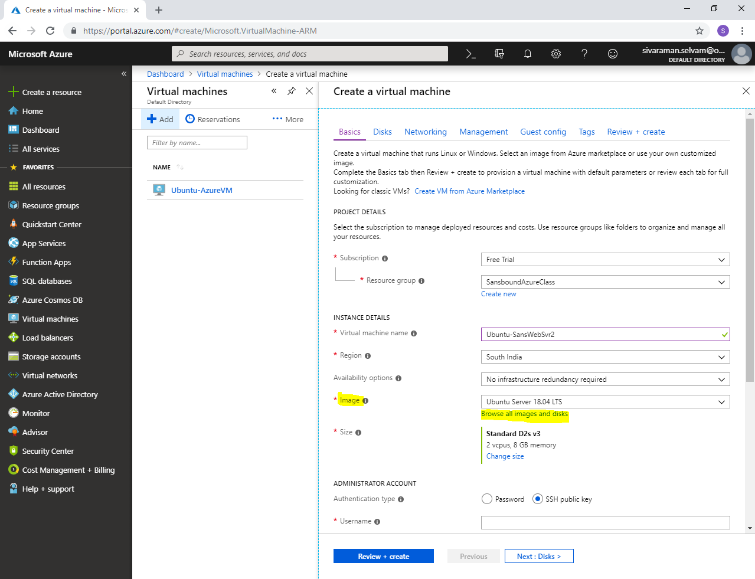

You need to click on **“My Items”** to view your own images.

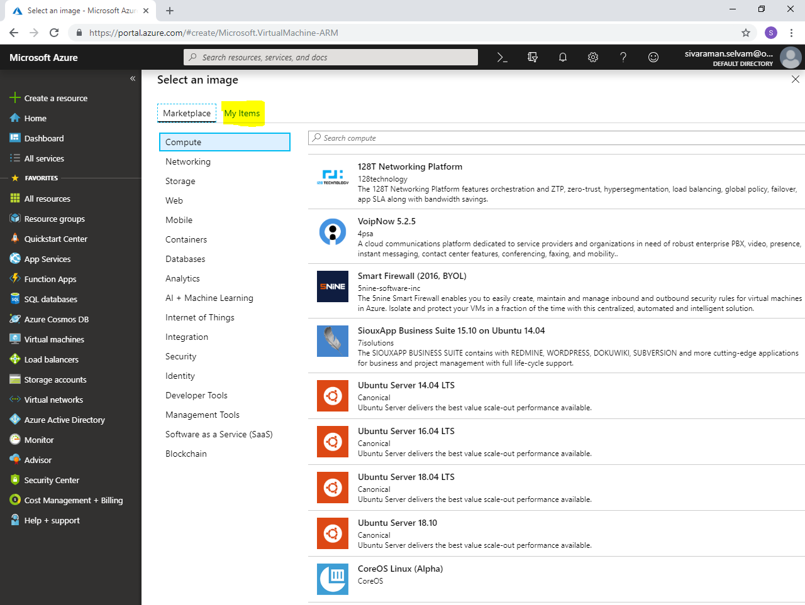

Here you are able see the **“Ubuntu-SansWebServer”** image.

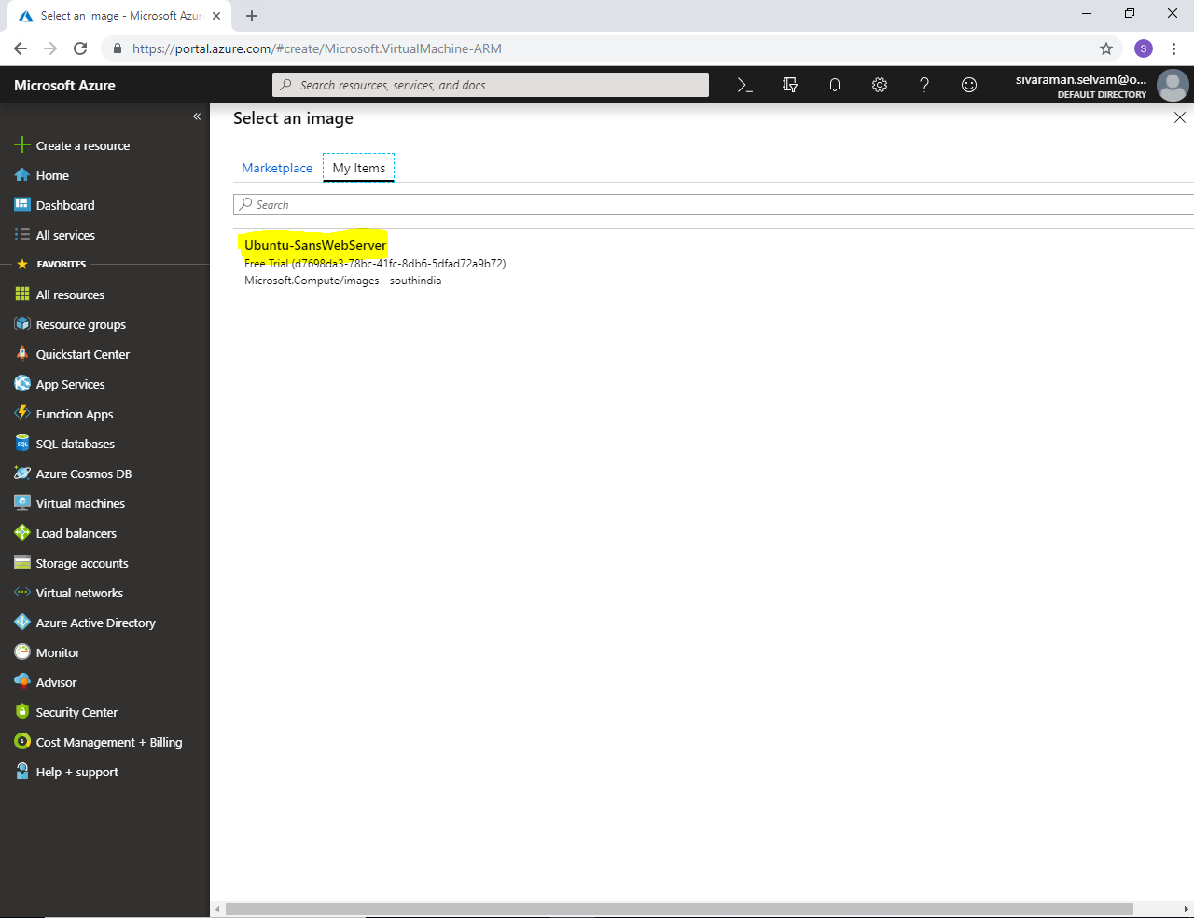

Click the Image **“Ubuntu-SansWebServer”** to select.

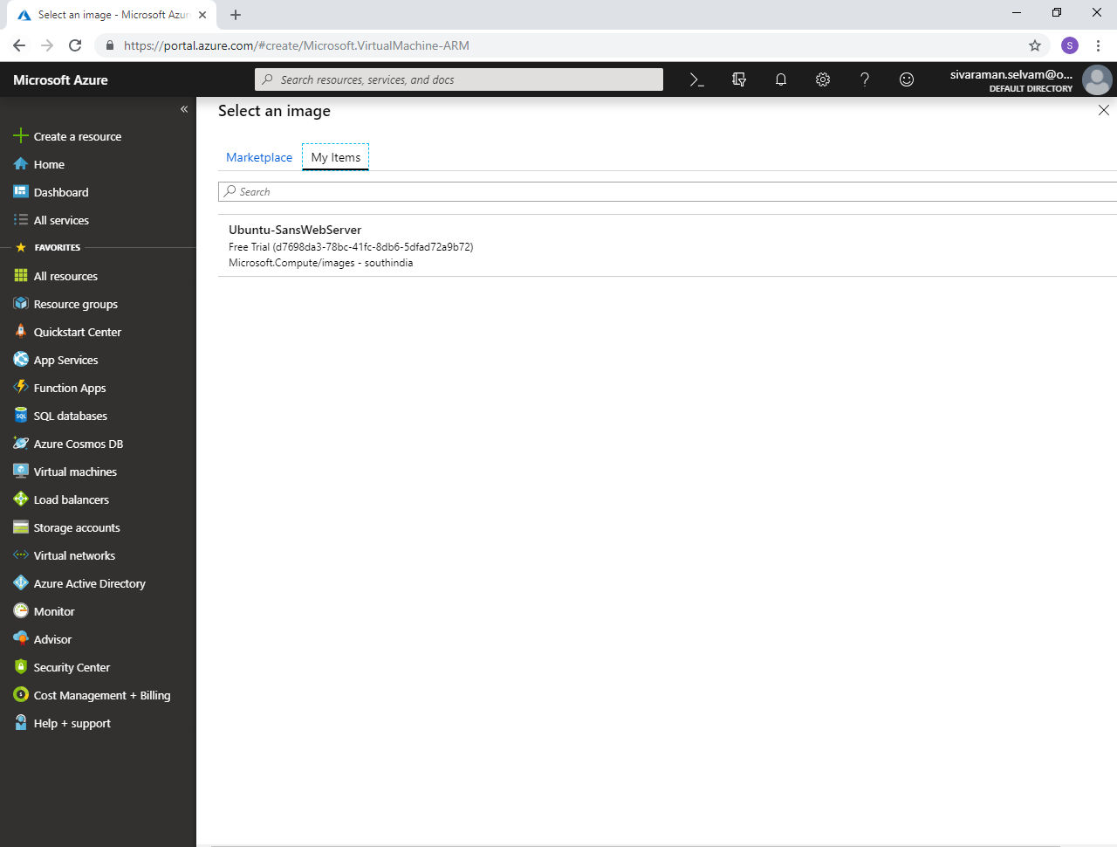

In **“Image”** ensure that your customized / own image **“Ubuntu-SansWebServer”** has been selected.

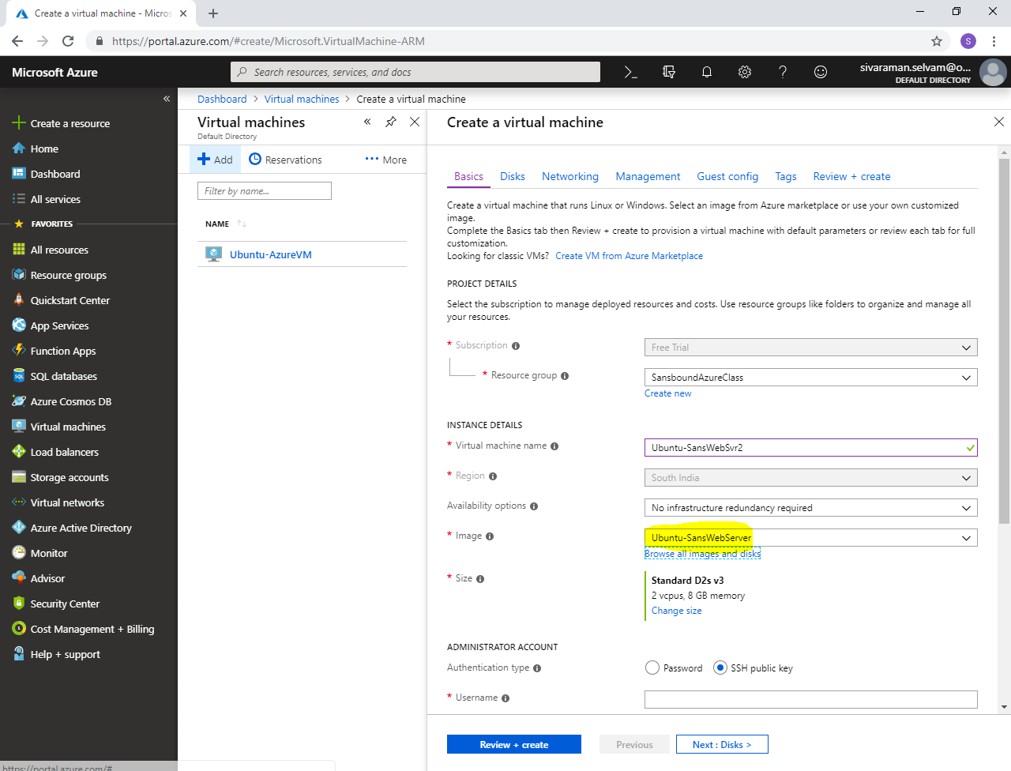

Change **“VM Size”** as **“Standard B1s”**

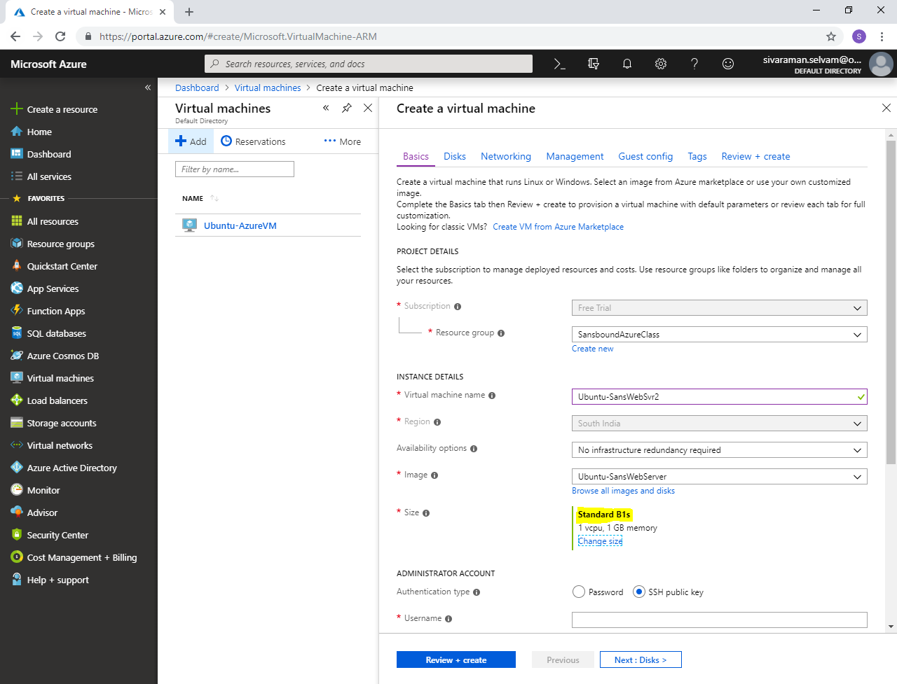

In **“Administrator Account”**

Set **“Authentication type”** as **“Password”**.

In **“Inbound Port Rules”.**

Pubic inbound ports as **“Allow selected ports”**.

In **“Select inbound ports”** need to check **“SSH”** and **“HTTP”**.

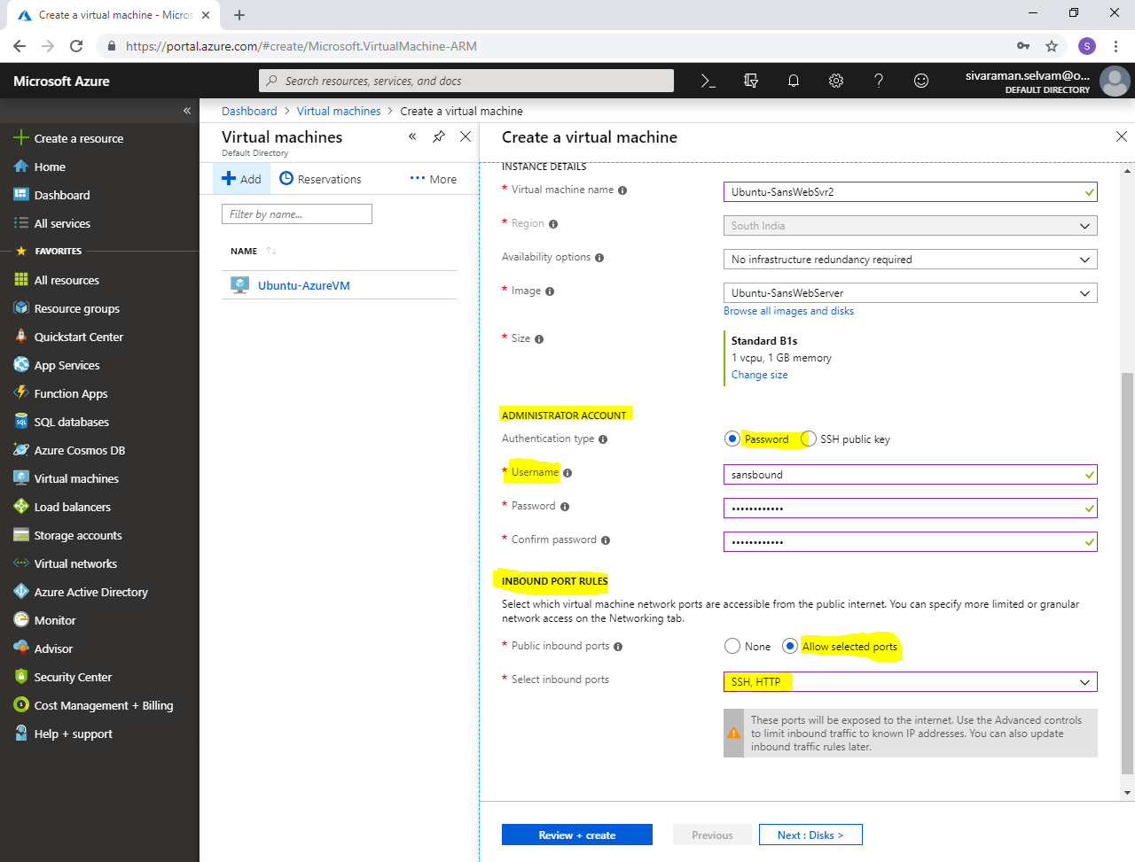

Click **“Next : Disks >”**.

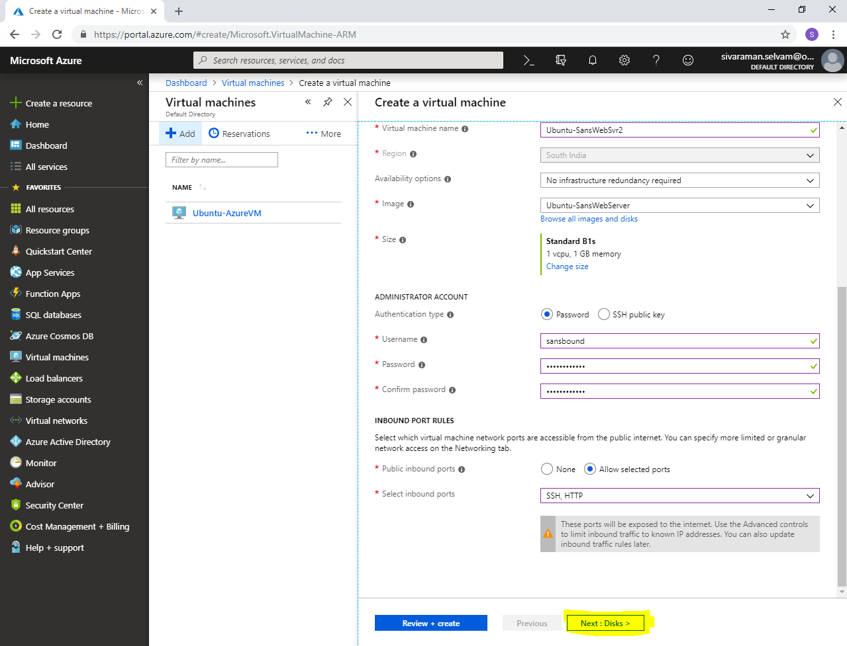

In **“Disks”**

In Advanced, you are able to see it have only “**managed disks”**. You would not be able to change the captured image disk as unmanaged disk.

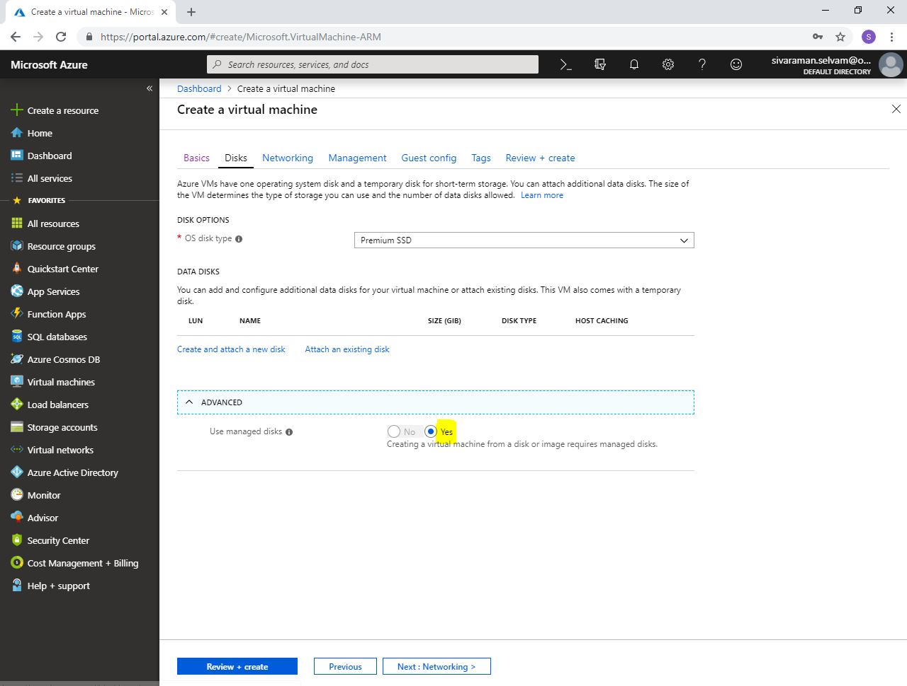

Click **“Next : Networking >”**.

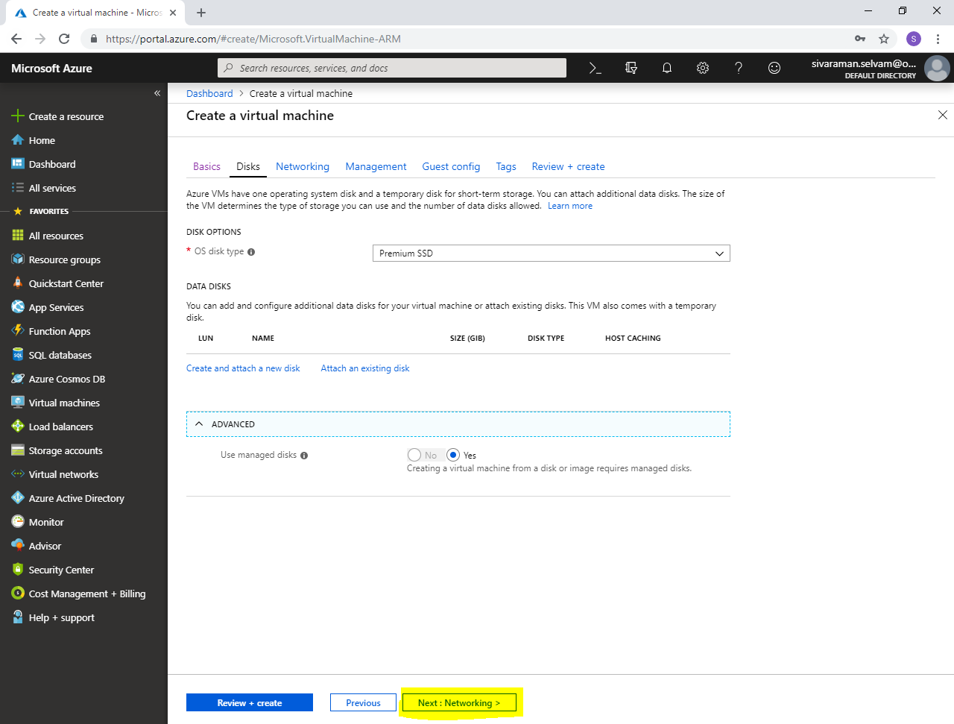

In **“Networking”**

You have required to ensure the below mentioned options.

Ensure Virtual network as **“SANS-VNET”**.

Ensure Subnet as **“Sans-Pub-Subnet”**.

Public IP for Ubuntu-SansWebSvr2

Ensure NSG type as **“Basic”** and **“Public inbound ports”** as **“Allowed selected ports”**.

Ensure “**Select inbound ports**” as **“SSH”** and **“HTTP”**

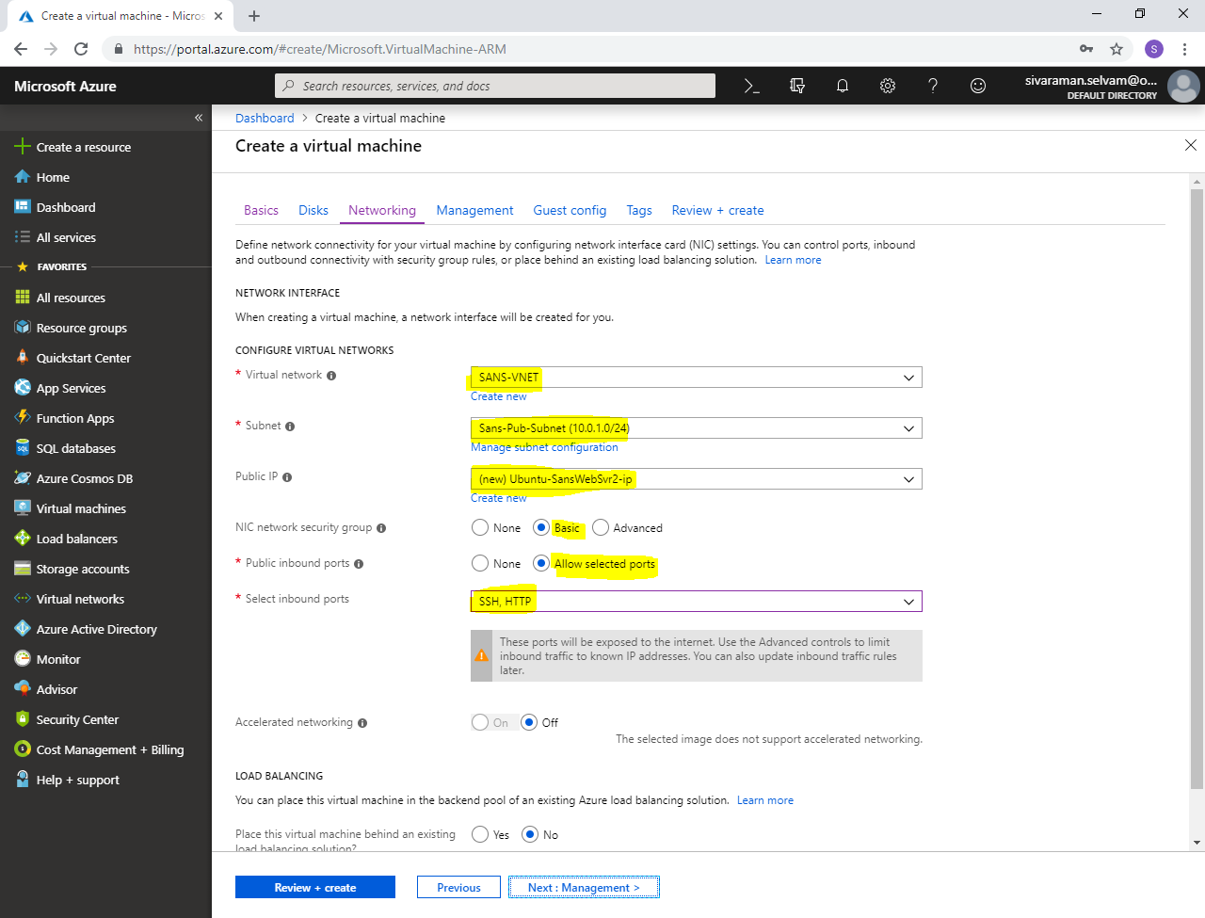

Click **“Next : Management >”**.

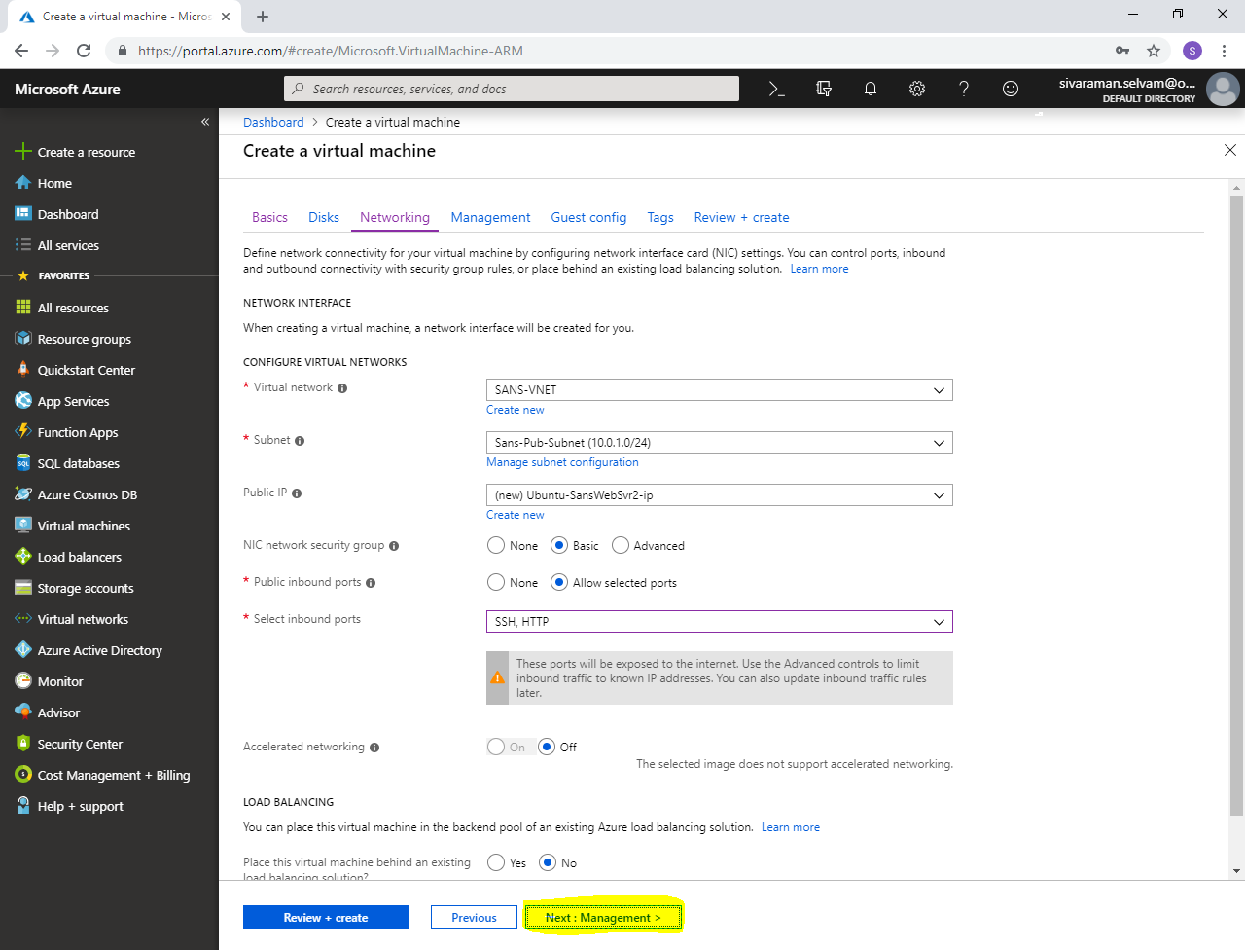

In **“Management”**

Click **“Next : Guest config >”**.

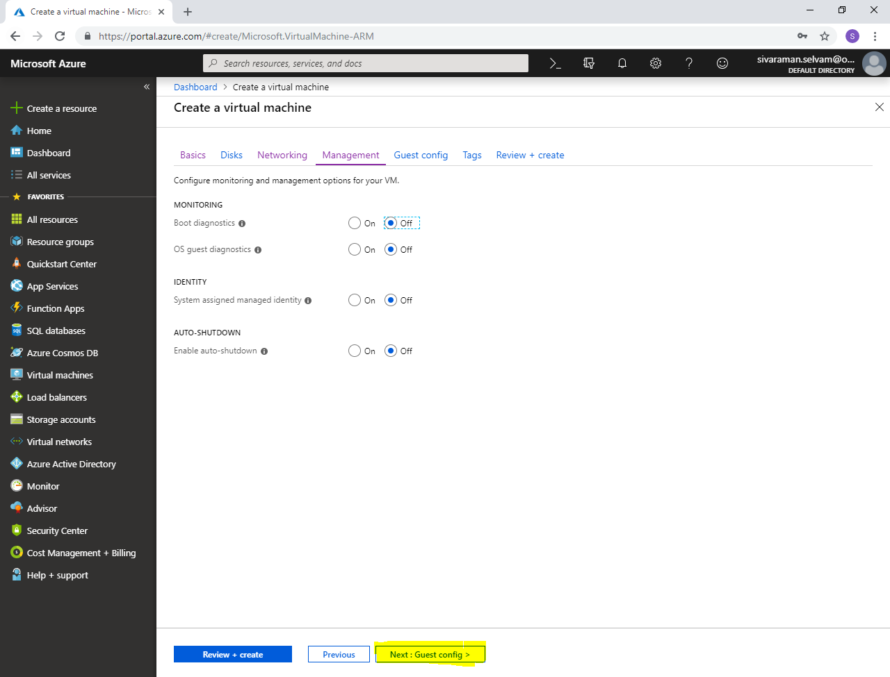

In **“Guest Config”**

Click **“Next : Tags >”**.

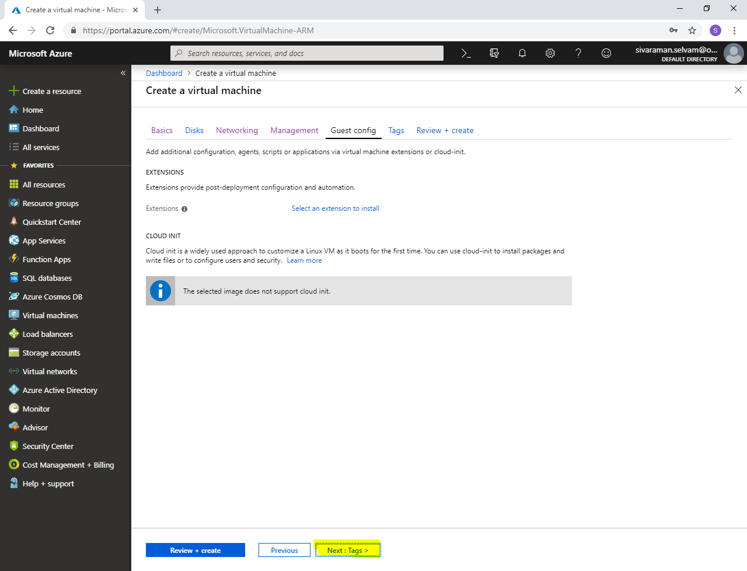

In **“Tags”**.

Click **“Review + create”**.

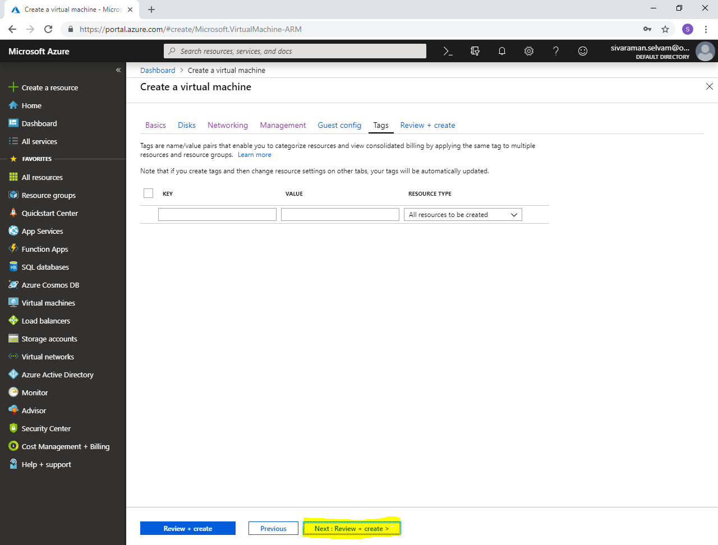

Click **“Create”.**

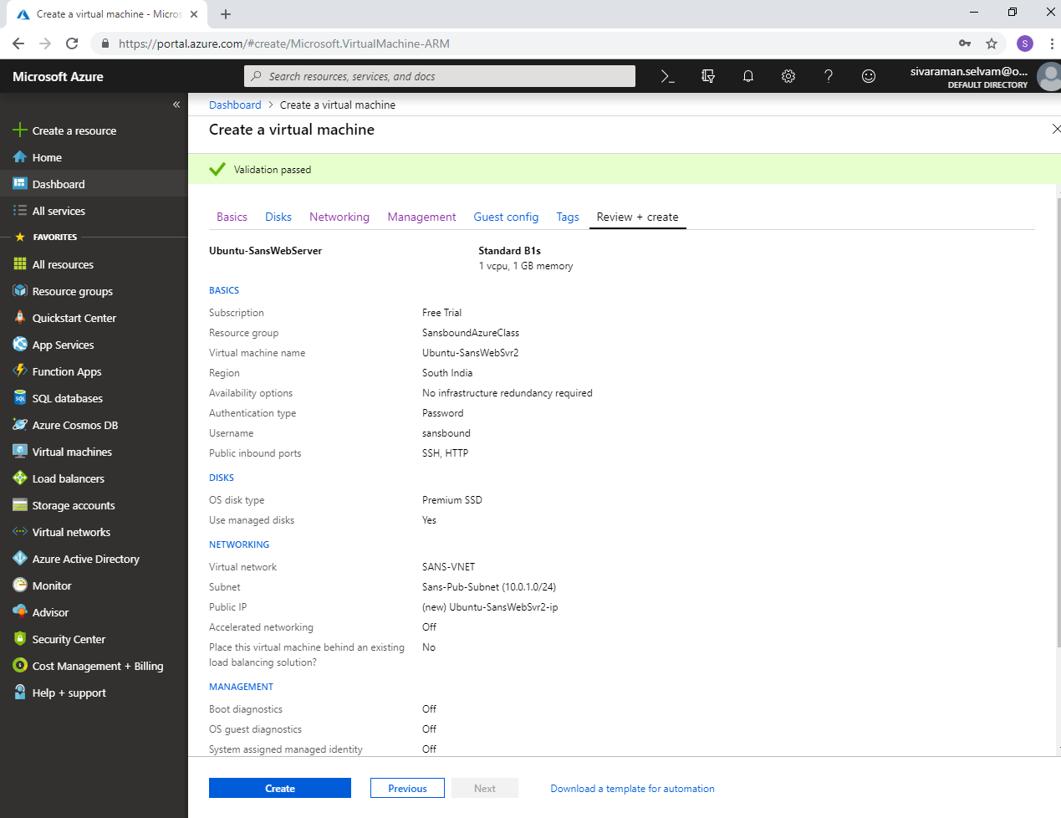

Your **“Virtual machine”** has been created successfully.

Click **“Go to resource”**.

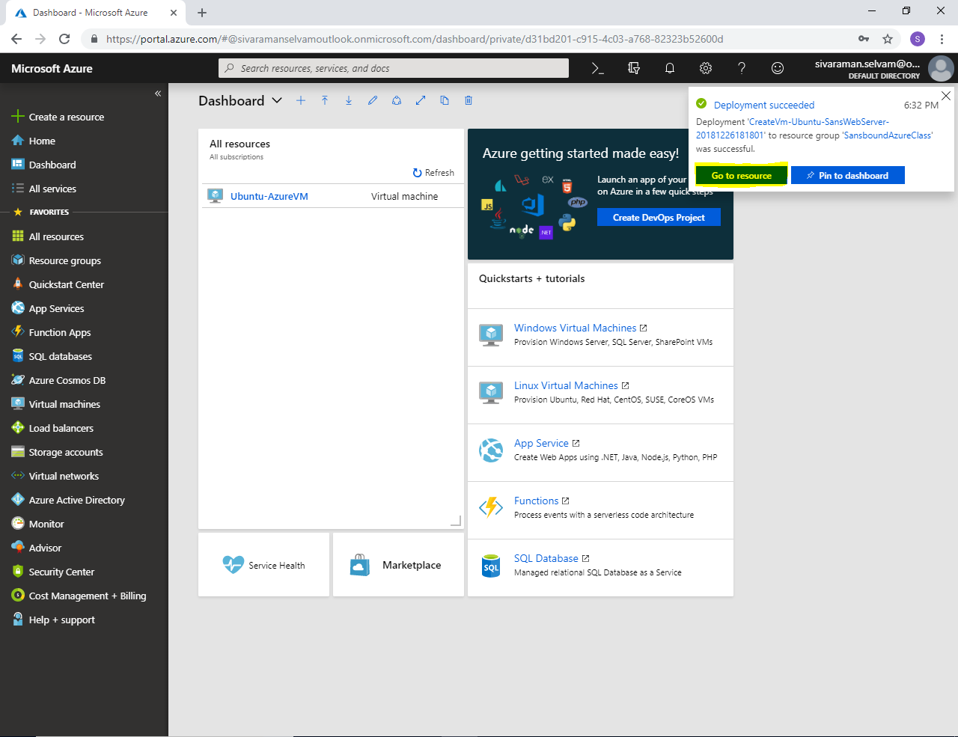

Kindly note the public IP address which you have got for “Ubuntu-SansWebSvr2” virtual machine.

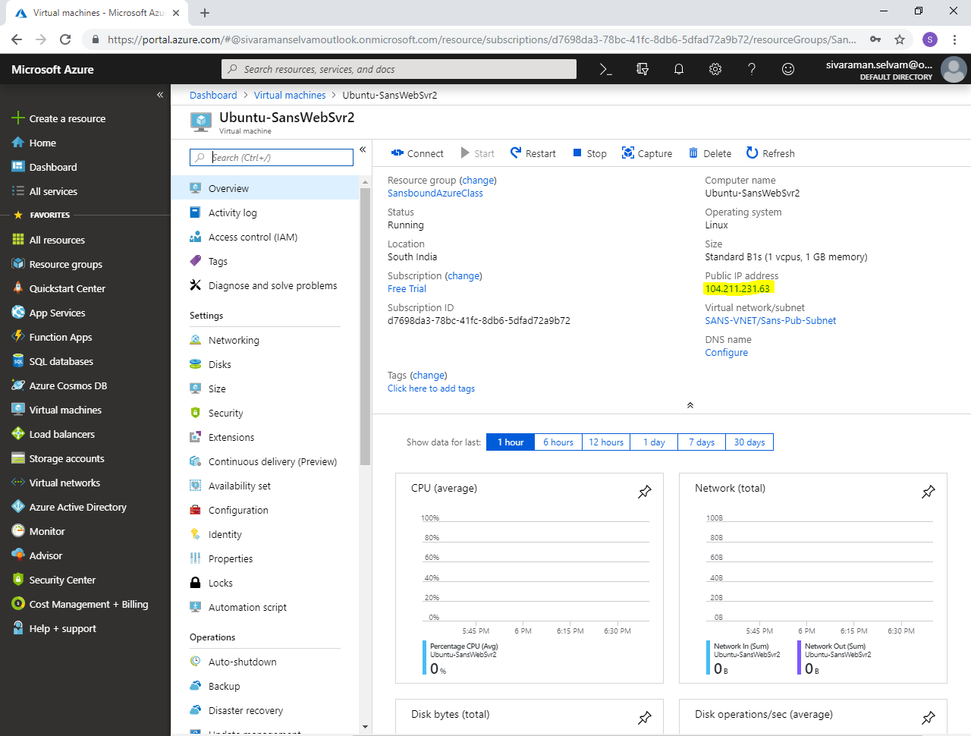

Type public IP address in your local machine browser and then press “Enter”.

I have got the customized webpage from captured VM.

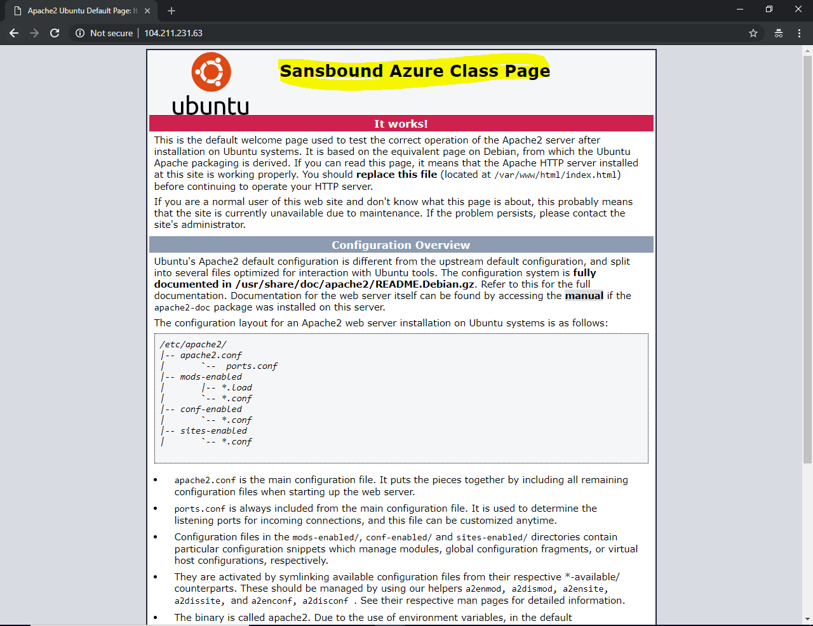

We have successfully captured the virtual machine successfully as Image and built new Virtual machine by using captured image.

When you have deleted the “Resource group” once you have completed the learning purpose lab. Then Captured Image in Azure has been deleted automatically.